Non official translation

PUBLIC DEBT
OF THE REPUBLIC OF ARMENIA

ANNUAL REPORT 2019

“The 2019 annual Report of the Public Debt of the Republic of Armenia” was published by edition of the Head of Public Debt Management Department Arshaluys Margaryan.
The materials have been prepared by the staff of Public Debt Management Department of MoF – A. Marutyan, N. Grigoryan, M. Harutyunyan, K. Ananyan, M. Hakobyan, V. Danielyan, S. Khanvelyan, K. Khachatryan, H. Stepanyan, S. Mkrtchyan, A. Hambardzumyan, M. Melikyan, G. Vardapetyan and A. Galoyan.

Content
Abbreviations 3
Macroeconomic Environment 4
RA Public Debt 6
RA Government Debt 11
RA Government Debt Service 16
Government Treasury Securities 18
The Secondary Market of the Government Treasury Securities 24
The Yield Curve of Coupon Bonds 25
Government Treasury Securities Retail Market 27
Foreign Currency Government Bonds 32
RA Government Loans and Credits 36
External Debt of the Central Bank of RA 43
Cash Flow Management 44
Risks Analysis 47
Annex 1. Government treasury securities transactions in 2019 57
Annex 2. Transactions of Eurobonds in 2019 67
Annex 3. New loan agreements signed in 2019 68
Annex 4. Transactions carried out during 2019 for the loans borrowed by the RA Government 69
Annex 5. Transactions carried out during 2019 for the loans borrowed by the Central Bank of RA 70
Annex 6. Transactions on the guarantees carried out during 2019 by the RA Government 71
Annex 7. Government treasury securities primary market agents in 2019 74

Abbreviations
GS | Government treasury securities
T-bills | Short-term bills
MTCN | Medium-term coupon notes
LTCB | Long-term coupon bonds
SCB | Saving coupon bonds
TD | Treasury Direct
GDP | Gross National Product  (Since 2015 the GDP is compiled by NSS RA according to System of national accounts 2008 (SNA 2008) international standard. GDP indicators for the period 2012-2014 have also been revised taking into account SNA 2008 and they are not consistent with the GDP indicators for the period 2000-2011, which had been compiled according to the System of national accounts 1993 (SNA 1993) standard. In May, 2019 the NSS of RA revised the GDP indicator for 2018.)
NPV | Net Present Value
MTEF | Medium-Term Expenditure Framework
TSA | Treasury Single Account
MoF of RA | Ministry of Finance of the Republic of Armenia
CBA | Central Bank of Armenia

As a result of rounding some numbers in the report, it is possible that the sum of components could deviate by decimal from the total sum indicator.

Macroeconomic Environment
In 2019 the economy developed faster compared to the previous year. The economic growth took place mainly due to the high growth of services and industry. The economic growth was accompanied with the growth of the domestic demand. Thus, services, industry and construction influenced positively on the economic growth, but the agriculture had a negative impact.
Economic growth: Economic growth in 2019 was 7.6%, which is higher by 2.4 percentage points compared to the previous year. Thus, services (5.5 percentage points), industry (1.5 percentage points) and construction (0.2 percentage points) contributed positively on the economic growth, growing by 10.7%, 8.3% and 3.7%, respectively. Agriculture had a negative impact on the economic growth (0.4 percentage points) decreasing by 2.6%.
External Sector – The negative balance of goods and services in dollar terms as a share of GDP was 14.4% improving by 1.2 percentage points compared to the previous year, which was due to the progressive growth of the export compared to the import (12.2% and 9.0%, respectively). Money transfers to the economy increased by 1.9% mainly due to the economic development in Russia. The deficit of the current account was improved also as a result of the negative balance decrease of the net investment incomes. As a result of the above mentioned developments, the balance of the current account deficit improved by 1.2 percentage points of GDP in 2019 compared to the previous year.
Exchange rate – In 2019 the average exchange rate amounted to 480.4 AMD against USD and appreciated by 0.5% compared to the average exchange rate of the previous year (483.0 AMD).
Inflation – As of December 2019, 12-month inflation comprised 0.7%, mainly due to the low inflation in some imported goods, as well as due to the decrease of the level of prices in some agricultural goods.
Public Budget – The course of fiscal policy was preserved in 2019. The contractionary fiscal policy was targeted and implemented aiming to maintain fiscal and debt sustainability along with the recovery of the economy. The total revenue of the state budget as a share of GDP made up 23.8% in 2019 against 22.3% in 2018. The share of the state budget taxes and duties to GDP ratio comprised 22.3% against 21.0% in the previous year.
The share of the state budget expenditures to GDP ratio increased by 0.8 percentage points, in which the share of current expenditures increased by 0.3 percentage points and the share of transactions with non-financial assets increased by 0.5 percentage points. In 2019 the share of the total state budget expenses to GDP ratio amounted to 24.8%, in which the current expenses were 21.9% and the transactions with non-financial assets made up 2.9%.
The state budget deficit amounted to AMD 63.9 billion in 2019 compared to the AMD 105.4 billion in the previous year. The state budget deficit to GDP ratio comprised 1% decreasing by 0.8 percentage points compared to the previous year.

RA Public Debt
As of December 31, 2019, the RA public debt amounted to AMD 3,513.4 billion or USD 7,324.2 million.

Public debt of the Republic of Armenia

 | 31.12.2018 |  | 31.12.2019
 | AMD billion | % of GDP | AMD billion | % of GDP
Public Debt of RA | 3,348.8 | 55.7 | 3,513.4 | 53.5
of which
Debt of the Government of RA | 3,082.7 | 51.2 | 3,278.7 | 49.9
of which
External Debt | 2,412.1 | 40.1 | 2,541.5 | 38.7
of which
Credits and loans | 2,002.6 |  | 2,067.3
Government treasury bonds purchased by non-residents | 3.6 |  | 3.3
Foreign currency denominated bonds purchased by non-residents | 402.1 |  | 467.1
External guarantees | 3.9 |  | 3.8
Domestic Debt | 670.5 | 11.1 | 737.2 | 11.2
of which
Credits and loans | 0.0 |  | 0.0
Government treasury bonds purchased by residents | 584.5 |  | 677.7
Foreign currency denominated bonds purchased by residents | 81.7 |  | 59.5
Domestic guarantees | 4.4 |  | 0.0
External Debt of the Central Bank of RA | 266.1 | 4.4 | 234.7 | 3.6
of which
Loans provided with the guarantee of the RA Government | 68.9 |  | 61.9

RA public debt increased by AMD 164.6 billion (USD 401.7 million) or by 4.9% in comparison to the previous year, of which RA Government debt increased by AMD 196.0 billion (USD 462.4 million) or by 6.4%, and the external debt of the Central Bank of RA decreased by AMD 31.4 billion (USD 60.7 million) or by 11.8%.

RA public debt and Public debt/GDP ratio dynamics

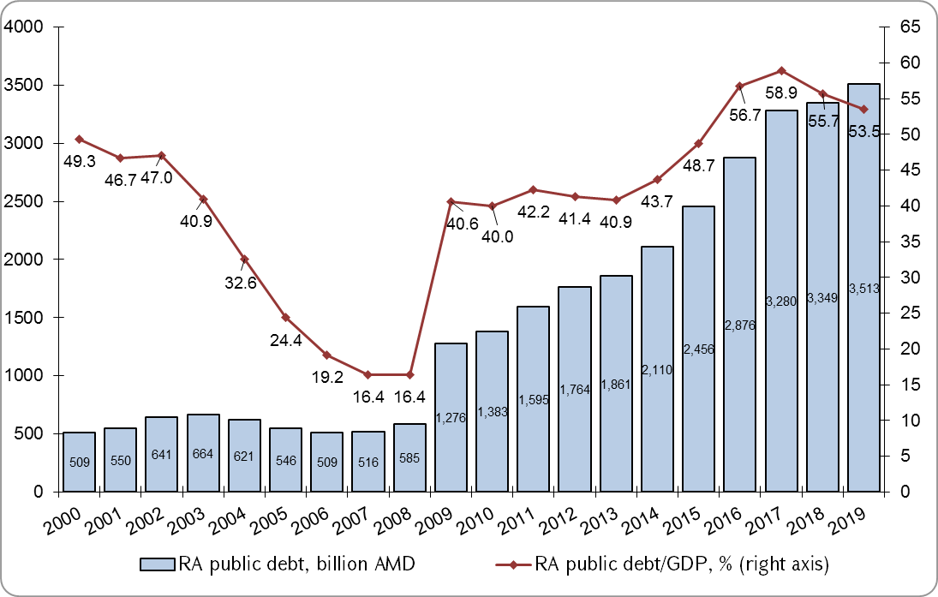

The public debt over GDP ratio amounted to 53.5% as of December 31, 2019, decreasing by 2.2 percentage points against the same indicator in the previous year, mainly due to the progressive growth of the nominal GDP (9.2% against 4.9% growth of the public debt). During the mentioned period RA external public debt increased by AMD 98.0 billion (USD 251.1 million) in absolute terms or by 3.7%. Moreover, the growth was only as a result of the increase of the RA Government external debt by AMD 129.4 billion (USD 311.8 million) or by 5.4%.
It was estimated in the 2020-2022 RA Government debt management strategy that the Government debt would be 3,370.6 billion or 52.2% of GDP at the end of 2019. However, the Government debt over GDP comprised 49.9% at the end of 2019, which was lower than the planned level by 2.3 percentage points.
In 2019 the public budget deficit financing through net borrowings (without promissory notes) actually comprised AMD 234.7 billion, which was more by AMD 9.3 billion than the RA state budget planned indicator.

Public budget deficit financing in expense of the net borrowings (without promissory notes)
(AMD billion) | 2018  Actual | 2019  Program | 2019  Adjusted program | 2019  Actual
Domestic sources | 48.0 | 70.0 | 88.9 | 101.9
External sources | 85.3 | 155.4 | 196.6 | 132.7
Total | 133.3 | 225.4 | 285.5 | 234.7

The planned indicators of the state budget deficit financing from the domestic and external sources, that were approved by the 2019 state budget and were envisaged in the 2020-2022 RA Government debt management strategy, had been corrected and raised by AMD 60.1 billion, of which AMD 18.9 billion from domestic sources and AMD 41.2 billion from external sources. The latter was due to the transactions organized for the buyback of Eurobonds maturing in 2020 and for issuance of new Eurobonds, which resulted AMD 41.2 billion net inflows to the RA state budget and than replenishment of the stabilization deposit account with the same amount aiming to repay the remaining (not presented for buyback) amount of Eurobonds during 2020. The performance of the indicator of deficit financing through net borrowings made up 82.2% compared to 2019 adjusted plan. Net borrowings from external sources amounted to AMD 132.7 billion or 56.6% of total financing and net borrowings from domestic sources amounted to AMD 101.9 billion or 43.4% of total financing.
The deviation between the actual and adjusted indicators of the deficit financing (without promissory notes) from domestic net sources by AMD 13 billion was performed along with high demand for GS and it is a consequence of targeting the reduction of exchange rate risk through the increase of the share of domestic net financing in the state budget deficit financing enshrined in the 2020-2022 RA Government debt management strategy.
The deviation between the actual and adjusted indicators of the deficit financing from external sources was due to the low performance of the project loans, where the actual disbursement amount made up AMD 99.5 billion against the planned AMD 166.5 billion.
The indicators, characterizing the burden of 2019 external public debt, are depicted below.

Characteristic indicators of the RA external public debt

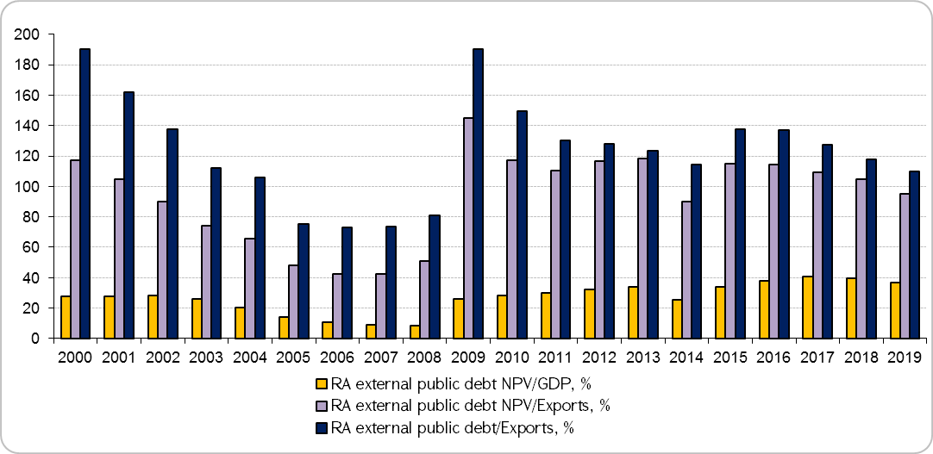
In comparison to the previous year RA external public debt NPV over GDP ratio decreased by 2.8 percentage points, meanwhile RA external public debt NPV over exports (export of goods and services) and RA external public debt over export ratios decreased correspondingly by 9.5 and 8.1 percentage points. These changes of the indicators can be explained by the following: RA external public debt NPV denominated in US dollar increased by 2.1%, and nominal GDP denominated in US dollar increased by 9.8%, as well as the export increased by 12.2%.

Characteristic indicators of the RA external public debt service

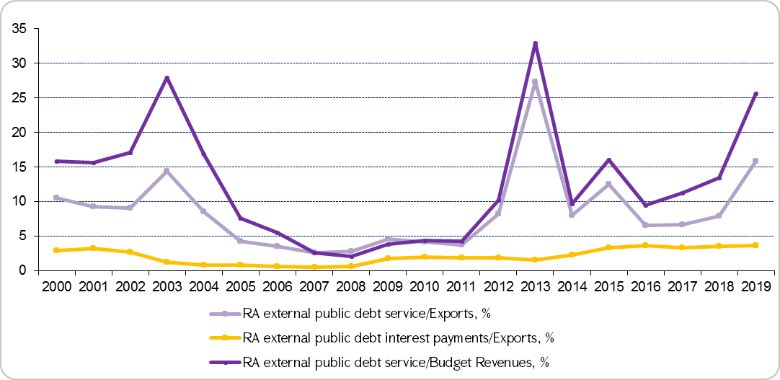
In comparison to the previous year RA external public debt service (redemption and interest payment) over Export indicator increased by 7.9 percentage points, and RA external public debt interest payments over Export indicator increased by 0.1 percentage points. The changes in these indicators are explained by the following: the increase of Export by 12.2% against 124.3% increase of the RA external debt payments due to the buyback of more than 80% of Eurobonds maturing in 2020, and the increase of RA external debt interest payments denominated in US dollar by 15.9%. RA external public debt service over the budget revenues indicator increased by 12.3 percentage points compared to the previous year, due to the progressive growth of external public debt payments against 17.3% increase of budget revenues denominated in USD.

RA Government Debt
Dynamics of RA Government debt and RA Government debt to GDP ratio are presented in chart 4.

RA Government debt and RA Government debt/GDP ratio dynamics in 2000-2019
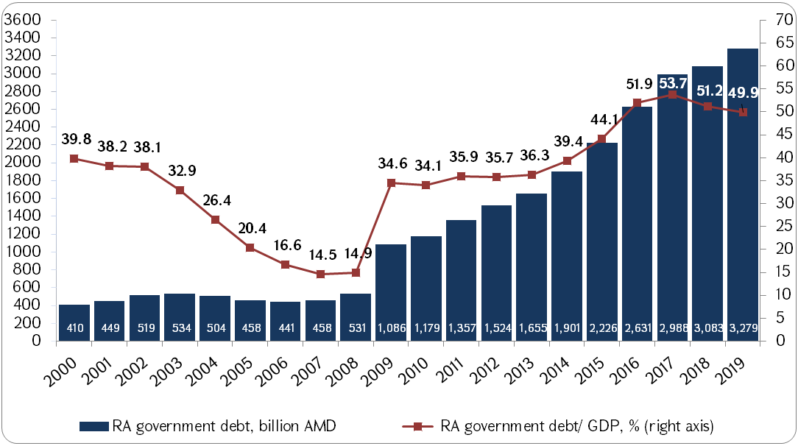
*Colored sections show the fiscal rule ranges

During 2000-2008 RA Government Debt/GDP ratio had been gradually declined from 39.8% to 14.5%. The decrease was mostly caused by AMD appreciation and double-digit GDP growth parallel with the slow increase of the Government debt. As a consequence of the global financial crisis, RA Government debt/GDP indicator had a drastic increase in 2009 amounting to 34.6% against 14.9% in 2008. The dynamic of RA Government debt growth accelerated also in 2014 as a result of AMD depreciation as a consequence of external economic shock, as well as, as a result of the increase of deficit net financing via borrowings. At the end of 2017 RA Government debt/GDP indicator comprised 53.7%. RA Government debt/GDP indicator gradually declined during 2018 and 2019 by 2.5 and 1.3 percentage points, respectively and totaled 49.9% in 2019 in line with the new fiscal rules system set up by the RA Government.

RA Government debt structure by instruments

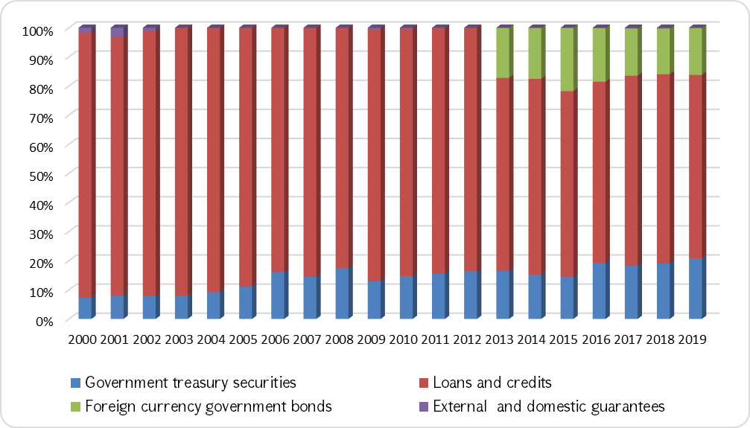
Since 2000 the share of the Government treasury securities has been gradually increased in the RA Government debt structure and comprised 19.1% in 2019. After entering into the international capital market for the first time in 2013 by the Republic of Armenia, the share of issued Foreign-currency denominated Government bonds comprised 16.1% in the RA Government debt in 2019. The share of loans and credits amounted to 63.1%, the share of external and domestic guarantees made up 0.1%.
Since 2000 the share of SDR denominated debt had been gradually diminished and amounted to 21.0% at the end of 2019. The share of JPY denominated debt also decreased and made up 3.3% against 3.7% in 2018. The share of USD denominated debt had been gradually increased comprising 43.9%.

RA Government debt structure by currency

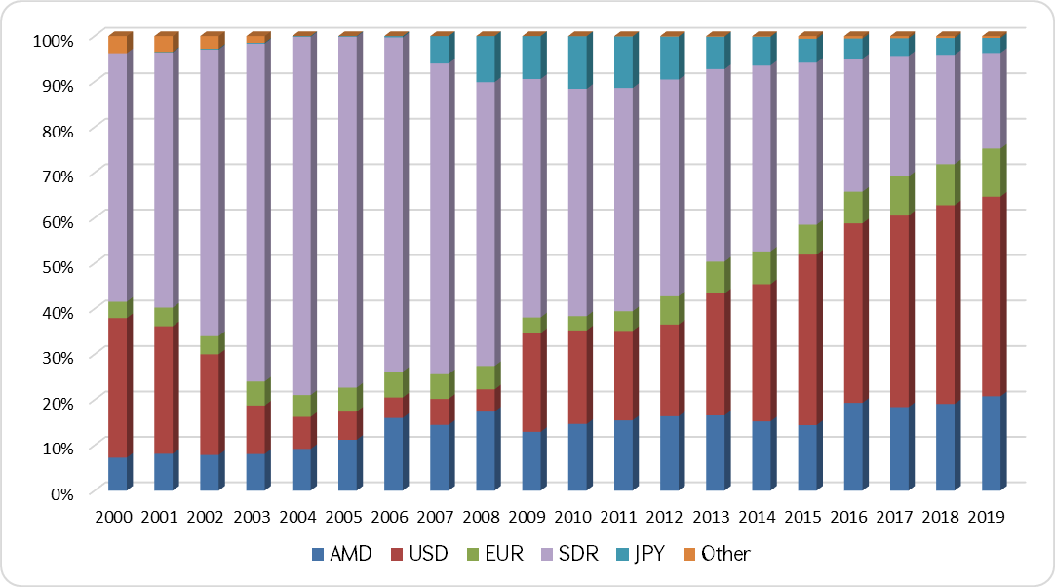
The share of Euro denominated debt increased as well and amounted to 10.6% against 9.2% in the previous year. This was mainly due to the fact that the currency of 5 credit agreements signed in 2019 was Euro, from which 4 agreements, being budget support credit agreements and totaling Euro 131.4 million, were completely disbursed during 2019. AMD denominated debt increased by 16.8% compared to the previous year, and as a result, the share of AMD denominated debt made up 20.8% in the currency structure of the RA Government debt at the end of 2019. The share of SDR denominated loans reduced and amounted to 21.0% against 24.1% in the previous year as a result of repayments.
Since 2000 the share of RA Government domestic debt has been gradually increased comprising 22.5% in 2019.

RA Government debt structure by residency
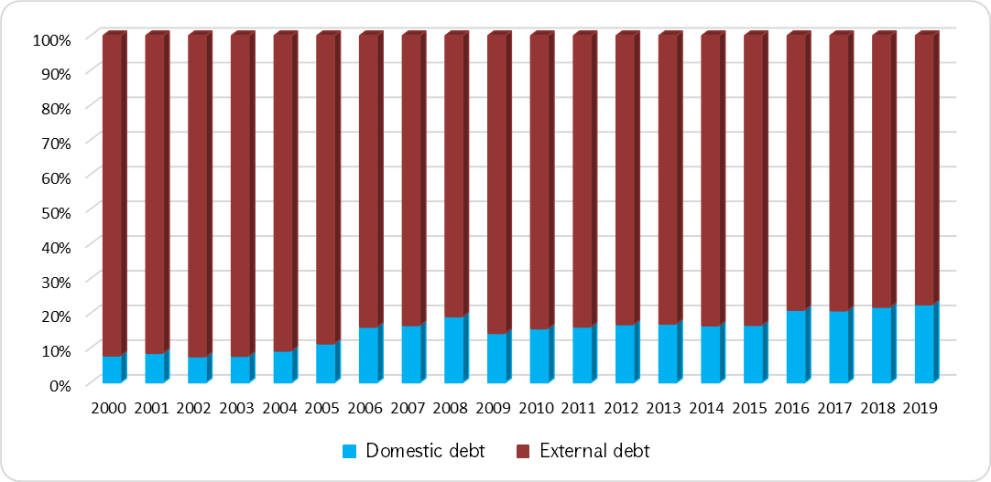
From 2000 to 2008 the share of fixed rate debt in the structure of RA Government debt had been gradually increased and reached to 98.4%. In 2019 the share of fixed rate debt indicator significantly reduced to 75.3% as a result of borrowing USD 500 million loan with floating rate by RA Government from Russian Federation in order to alleviate the impact of global financial crisis. In 2013 the share of fixed rate debt increased again due to the issuance of fixed rate Eurobonds and fully repayment of the above mentioned floating rate loan.

RA Government debt structure by interest type
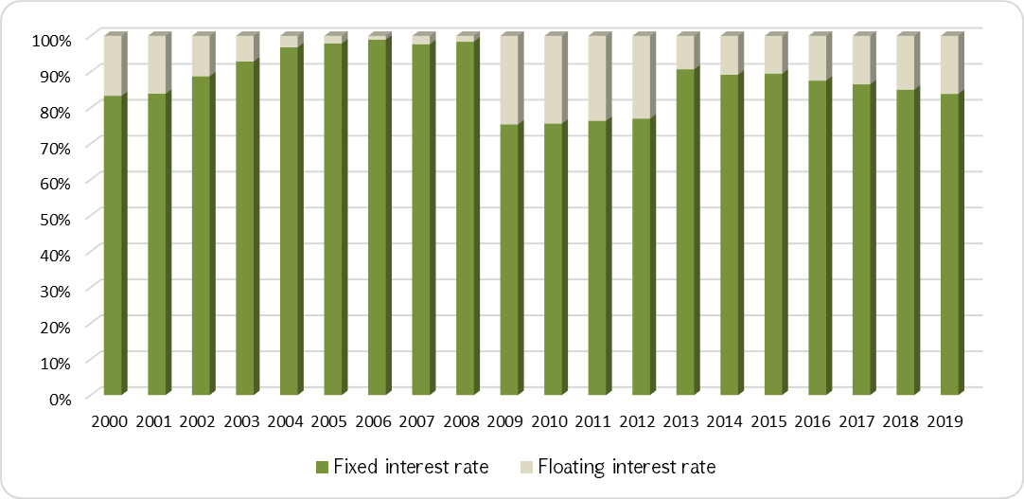

In recent years international creditors have been reviewed the terms of previously provided loans, and especially newly providing loans, by increasing the share of floating rate loans. The share of fixed rate debt amounted to 83.8% in the structure of RA Government debt at the end of 2019.

RA Government debt structure by market and non-market instruments

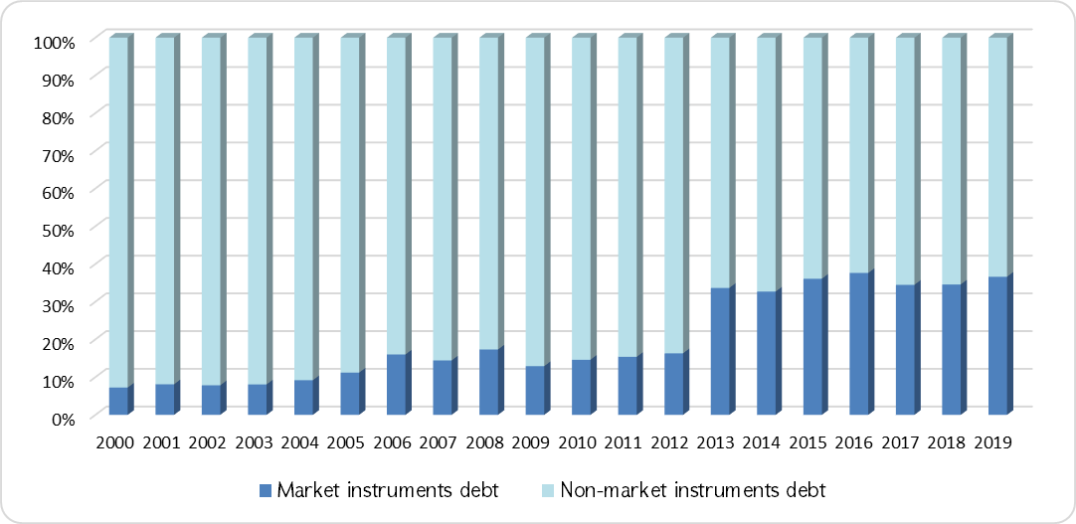
The factors of issuing Eurobonds in 2013, 2015 and 2019, as well as the repayment of the Russian Federation loan in 2013 had been essentially contributed to the increase of the share of Marketable instrument debt in the RA Government debt structure since 2013. The share of Marketable instrument debt comprised 36.6% in 2019.

RA Government Debt Service
As in the previous years, in 2019 the Government of Armenia completely and timely fulfilled its obligations on interest payments and debt repayments.

RA Government interest payments (billion AMD)
 | 2018 | 2019 | 2019 | 2019
 | Actual | Program | Adjusted program | Actual
Interest payments | 139.0 | 158.0 | 160.2 | 157.5
By residency
Domestic Debt payments | 64.0 | 68.8 | 70.3 | 69.7
External Debt payments | 75.0 | 89.1 | 89.9 | 87.8
By instruments
External loans and credits | 43.2 | 57.2 | 51.8 | 49.6
Government treasury securities | 64.0 | 68.8 | 70.3 | 69.7
Foreign currency Government bonds | 31.8 | 32.0 | 38.1 | 38.1

RA Government interest payments amounted to AMD 157.5 billion in 2019, which are more by AMD 18.5 billion or 13.3% than in the previous year. Interest payments increased for GS by 9.0%, for loans received from external sources by 14.8% and for foreign currency denominated GS by 20.0%. The share of interest payments over the state budget expenditures increased by 0.1 percentage points and amounted to 9.7% in 2019. The share of service expenses over GDP also increased by 0.1 percentage points comprising 2.4%.
The savings in external loans and credit services against the program indicator envisaged by the 2020-2022 RA Government debt management strategy and adopted by 2019 state budget of RA and against the adjusted program amounted to AMD 7.5 billion and AMD 2.1 billion, respectively, which was due to the significant underperformance of the disbursement program amount for a number of loans during 2018-2019, as well as the differences between the forecasted and actually applied rates of 6 months USD LIBOR and 6 months EURIBOR in 2019.
GS interest payments program envisaged by the 2020-2022 RA Government debt management strategy and adopted by 2019 state budget increased by AMD 1.4 billion during the year due to the actually AMD 31.9 billion higher deficit financing by GS against the initially planned indicator. AMD 0.54 billion savings of GS interest payments against the revised program indicator was due to the differences between forecasted and actual yields.
The increase of interest payments for foreign currency denominated GS by AMD 6.1 billion compared to the program indicator envisaged by the 2020-2022 RA Government debt management strategy and adopted by 2019 state budget, as well as AMD 6.4 billion increase of actual interest payments compared to the same indicator in 2018 were mainly due to the paid premium for the partially USD 402.4 million buyback of Eurobonds maturing in 2020.
The increase of the RA Government debt service expenses was firstly as a result of the increase of the Government debt by 6.4% in 2019 compared to 2018. The increase was also due to:
- The increase of the volume of Government treasury securities by AMD 92.9 billion and the share of long-term coupon bonds in the structure of the Government treasury securities by 8.5 percentage points. The total service expenses of Government treasury securities increased by AMD 5.7 billion.
- The change in the applicable exchange rates for the foreign currency payments (particularly, the USD exchange rate increased from 483.0 to 486.55 or by 0.7%).

The weighted average nominal interest rate amounted to 4.8% as of December 31, 2019 and decreased by 0.2 percentage points compared to the end of the previous year. The changes in this indicator by separate instruments are the following:

Average interest rates of the RA Government debt
 | 31.12.2018 | 31.12.2019 | Difference
Average interest rate of the RA Government debt, % | 5.0 | 4.8 | (0.2)
External loans and credits interest rate | 2.4 | 2.3 | (0.1)
Government treasury securities interest rate | 12.3 | 11.8 | (0.5)
Foreign currency Government bonds interest rate | 6.9 | 5.9 | (1.0)
External guarantees interest rate | 1.0 | 1.0 | -

The decrease of the above-mentioned indicator for external loans by 0.1 percentage points was due to the changes of LIBOR rate, which is the basis for calculations of service expenses for floating rate loans.
The average rate of 6 months USD LIBOR was 2.49% in 2018 and it was 2.32% in 2019. The service of about 23% of the external loans is based on LIBOR (as of the end of 2019).

Government Treasury Securities
The budget deficit was planned to be financed through Government treasury securities by AMD 70.0 billion according to the 2020-2022 RA Government debt management strategy and 2019 state budget of RA. This indicator was adjusted later and amounted to AMD 88.9 billion, but the actual deficit financing through GS comprised 101.9 at the end of 2019.
In 2019, the total amount of Government securities allocation was AMD 209.9 billion, and the proceeds from allocations amounted to AMD 217.3 billion. Meanwhile, the actual amount for the total buybacks and redemptions made up AMD 115.3 billion.
Monthly and accumulative data of the budget deficit financing through GS during the year are presented in table 5.

Monthly and accumulative data of the budget deficit financing through GS (AMD million)

 | Monthly |  | Monthly  (accumulative)
 | 2018 | 2019 | 2018 | 2019
January | 20,130 | 10,725 | 20,130 | 10,725
February | (14,059) | 9,491 | 6,071 | 20,216
March | 8,194 | 8,708 | 14,264 | 28,924
April | 17,046 | (11,881) | 31,311 | 17,042
May | (35,463) | 7,106 | (4,152) | 24,148
June | (1,158) | 2,528 | (5,310) | 26,676
July | 25,188 | 42,297 | 19,878 | 68,974
August | 6,680 | 3,355 | 26,558 | 72,328
September | (1,283) | 1,610 | 25,275 | 73,939
October | 7,909 | 25,961 | 33,185 | 99,900
November | 7,556 | 2,064 | 40,740 | 101,964
December | 7,236 | (14) | 47,976 | 101,950

Monthly and accumulative financing of RA state budget deficit (AMD billion)

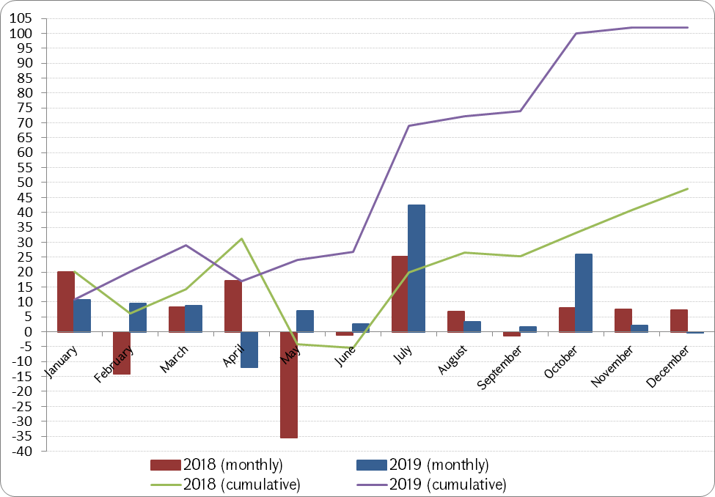
The dynamic of accumulative financing of RA 2019 state budget deficit declined in April due to the large redemption of the Government securities and it increased sharply as a result of high volume allocations in July and in October: AMD 48.8 billion maturing in 2029 and AMD 25.2 billion maturing in 2047, respectively.
According to the 2020-2022 RA Government debt management strategy the nominal volume of outstanding GS should had been AMD 655.6 billion, but it amounted to AMD 681.0 billion exceeding program indicator by AMD 25.4 billion. As we have already mentioned, it was due to targeting the reduction of exchange rate risk through the increase of the share of domestic net financing (without promissory notes) in the state budget deficit funding enshrined in the 2020-2022 RA Government debt management strategy, along with high demand for GS (the demand for GS exceeded the allocation volume by 2.1 times).
As of December 31, 2019, the volume of outstanding GS was more by AMD 92.9 billion or by 15.8% in comparison to the same indicator in the previous year. The structure of GS was as follows:

Outstanding GS structure

 | 2018 |  | 2019
 | (billion AMD) | Share | (billion AMD) | Share
T-bills | 29.1 | 4.9% | 23.8 | 3.5%
MTCN | 230.1 | 39.1% | 218.6 | 32.1%
LTCB | 323.2 | 54.9% | 431.9 | 63.4%
SCB | 5.7 | 1.0% | 6.7 | 1.0%
Total securities | 588.1 | 100% | 681.0 | 100%

As of the end of the year, the residents owned the 99.5% of GS or AMD 677.7 billion, and the non-residents owned the 0.5% or AMD 3.3 billion.
As of December 31, 2019, the structure of GS by date to maturity was as follows:

GS structure by date to maturity as of December 31, 2019

 | Program | Actual
Up to 1 year | 14.0% | 12.7%
1-5 years | 45.5% | 28.8%
5 and more years | 40.5% | 58.5%

The deviation of “The structure of GS by days to maturity” indicator envisaged in the 2020-2022 RA Government debt management strategy from the actual one was mainly due to the high volume issuances of long-term bonds.
The annex 1 includes information on transactions with GS.
As of December 31, 2019, the weighted average maturity of GS amounted to 3734 days against 3308 days as of December 31, 2018, and the weighted average yield was 11.78% (12.28% as of December 31, 2018).

GS average yield and maturity dynamics in 2019

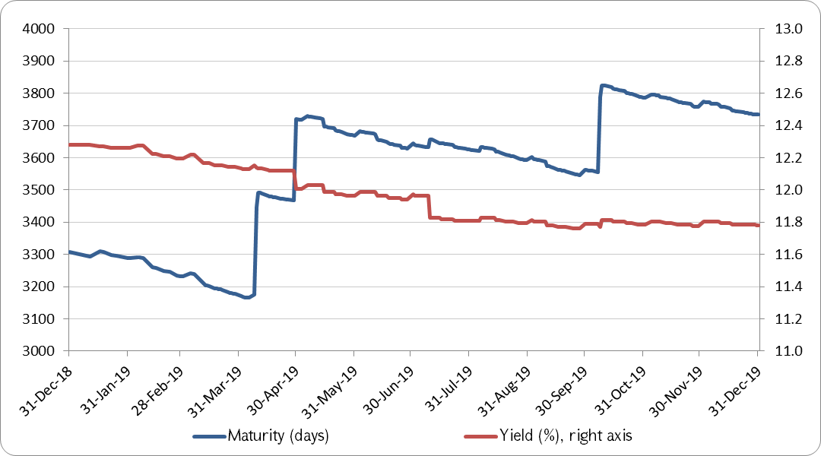
As a result of the year, the Government succeeded in extension of the weighted average maturity of GS by 426 days and in reduction of the weighted average yield of GS by 0.5 percentage points, which was mainly contributed by the decrease of the weighted average yield of the high volume primary allocations of LTCB and buyback and redemption of the high-level yield GS during 2019. In 2019, the weighted average yield of the primary allocations of GS increased by 0.12 percentage points compared to the same period of the previous year and amounted to 8.97%, which was related to the significant increase in allocation volumes in the long-term segment on the yield curve against the short-term segment compared to the previous year.

GS Structure by issuing maturity as of December 31, 2019

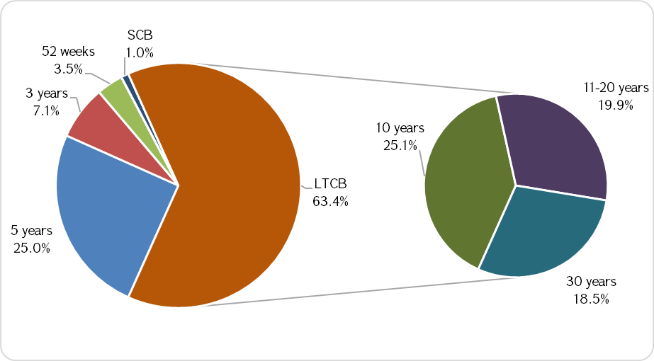
The volume of SCB outstanding as of December 31, 2019 increased by 17.2% amounting to AMD 6,731.8 million. The detailed information on GS retail market transactions during 2019 is presented in “Government Treasury Securities Retail Market” subsection.
Along with the increase of volumes of outstanding GS, the redemption and interest payments increase as well.

The distribution of GS redemption and interest payments during the year (AMD million)
 | Redemption |  | Interest payments
 | 2018 | 2019 | 2018 | 2019
January | 6,628 | 7,202 | 362 | 643
February | 27,268 | 2,380 | 6,635 | 4,879
March | 4,280 | 3,480 | 3,332 | 4,790
April | 5,567 | 48,655 | 694 | 22,312
May | 47,162 | 3,430 | 21,669 | 202
June | 4,909 | 8,685 | 313 | 715
July | 7,091 | 8,460 | 738 | 797
August | 3,772 | 5,211 | 5,040 | 4,725
September | 4,970 | 6,605 | 4,864 | 6,851
October | 2,422 | 7,284 | 20,066 | 22,978
November | 3,997 | 6,358 | 168 | 451
December | 123 | 7,552 | 111 | 396
Total | 118,190 | 115,301 | 63,991 | 69,738
The large repayment amount in April 2019 was the redemption of previously allocated 3-year and 5-year maturity benchmark GS. The significant volumes of the service expenses in April and in October were due to the service of issued benchmark GS.
The information on GS transactions during 2019 is presented in Annex 1.
Bank investors still prevail in the structure of GS, the share of which amounted to 79.3% at the end of the year, including 66.5% share of bank investors and 12.8% share of CBA.

GS structure by investors

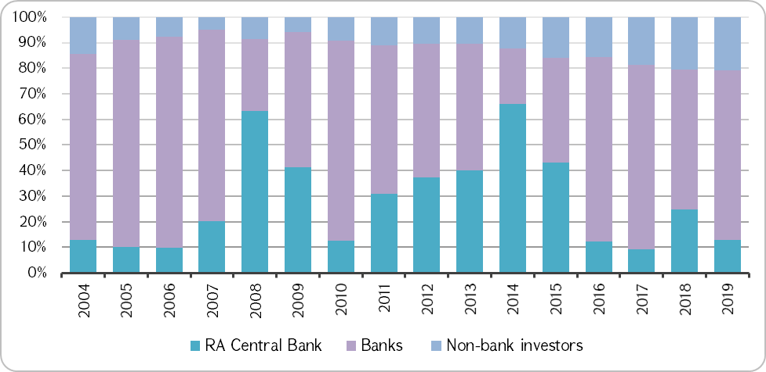

Since 2009 the share of Non-Bank investors had been gradually increased in the structure of GS and totaled 20.7% in 2019.

The Secondary Market of the Government Treasury Securities

Compared to the previous year, the number of transactions in the secondary market grew by 40.6% and the amount of transactions increased by 16.9%. The share of transactions in the over-the-counter amounted to 88.6% in the total amount of transactions, and the share of stock exchange transactions amounted to 11.4% against 87.1% and 12.9% in the previous year, respectively. In 2019 the weighted average yield of transactions decreased by 1.57 percentage points, and the weighted average maturity of transactions declined by 24.4%.
The main characteristics of the secondary market transactions are presented below.

General indicators of the GS transactions implemented in the secondary market

 | 2017 | 2018 | 2019
The number of transactions (quantity) | 1,848 | 1764 | 2481
The total amount of transactions (AMD billion),  of which | 371.4 | 388.6 | 454.2
Interbank market | 307.1 | 338.4 | 402.3
Armenia Securities Exchange (AMX) | 61.3 | 50.2 | 51.9
CBA transactions | 3.0 | - | -
Secondary market indicators
Weighted average yields of all transactions (%) | 10.32 | 10.86 | 9.29
Weighted average time to maturity (days) | 4,319 | 6,819 | 5,157
Weighted daily average amount (AMD million) | 1,491 | 1,632 | 1,854
Daily average number of transactions | 7 | 7 | 10

The average daily number of transactions increased and amounted to 10 transactions against 7 transactions in the previous years, as well as the average daily volume increased by 13.6%.

The Yield Curve of Coupon Bonds
According to the 11.10.2016 N 1/710A decree of the Governor of the Central Bank of the Republic of Armenia, the average yields of buy and sell quotations of the coupon bonds listed during the stock exchange trading session and the yields of the transactions carried out in the secondary market with the coupon bonds with 366 days or more maturity are being used in order to build a yield curve of coupon bonds.
RA yield curve of the coupon bonds has a normal shape, which means that the market demands higher yield for one day or more days longer maturity debt, and the marginal yield has a decreasing trend. The yield curve had a clearly observed downward trend over the years, moreover, the long-term part of the curve decreased faster than the short-term or medium-term parts.

Coupon bond yield to maturities as of December 31, 2016-2019
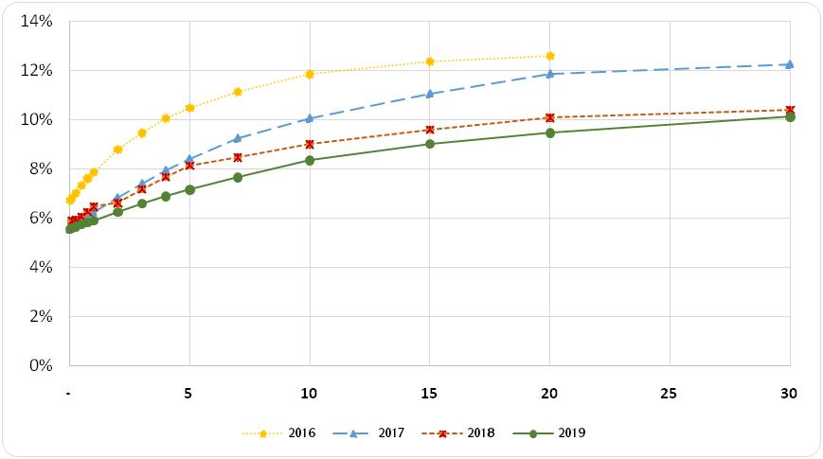
A research of the dynamics of 2016-2019 yield curves shows that the yields on all maturity coupon bonds had decreased during the observed period. As of December 31, 2017, the yield on 30-year coupon bond was 12.3%, and as of December 31, 2019 it was 10.1%.

The spread of RA coupon bond yields to maturity vs US treasury yields with the same maturities, 2016-2019
(basis points)
Maturity  in years | 30.12.2016 |  | 29.12.2017 |  | 28.12.2018 |  | 30.12.2019
1 | 704 | 449 |  | 406 |  | 436
2 | 759 | 496 |  | 467 |  | 469
3 | 800 | 542 |  | 518 |  | 502
5 | 857 | 621 |  | 592 |  | 548
7 | 889 | 693 |  | 638 |  | 586
10 | 940 | 766 |  | 689 |  | 646
20 | 980 | 931 |  | 753 |  | 727
30 |  | 953 |  | 766 |  | 778

It is important to compare the yield trends of RA coupon bonds with the yields in the international markets, especially with the US Treasury bonds, when presenting a trend of declining yield and an increase in confidence. The Spread's dynamic against US bonds for the same maturity had also a declining trend during 2016-2019. Thus, if the yield of GS with a one-year maturity was more by 704 basis points or 7.04 percentage points against US bonds with the same maturity as of 30.12.2016, then as of 31.12.2019 the same indicator was more only by 436 basis points or by 4.36 percentage points (it decreased by 268 basis points). In addition, the yield difference of 30-year maturity GS against US bonds with the same maturity decreased from 9.53 percentage points as of 29.12.2017 to 7.78 percentage points (less by 175 basis points) as of 30.12.2019.

Government Treasury Securities Retail Market
The retail sale of GS is organized through the Treasury Direct system, the main functions of which are organization of the retail sale and buybacks of securities, implementation of refinancing, free delivery of securities, provision of extracts and references, as well as carrying out the current payments, redeemed and buyback payments to investors.
The investors can acquire GS, carry out buybacks and get information on GS new issuances not only visiting the service centers, but also entering into the online system via “gp.minfin.am” website.
It is possible to acquire not only saving coupon bonds, but also Government short-term, medium-term and long-term bonds through the Treasury Direct. Treasury short-term bills, medium-term and long-term coupon bonds are being allocated through the Treasury Direct in the form of direct sale with an amount of up to ten percent of the total volume or the maximum volume of the range of each allocation auction.
Since 8 October, 2019 “gp.minfin.am” online system of the Treasury Direct has also become available outside the geographical area of the RA.
In 2019 the transactions implemented in the retail market were as follows:
- TD allocated all 41 issues of SCBs, as well as carried out investments in one T-bill, one MTCN and two LTCB issuances,
- GS investment amount through TD made up AMD 5,755.7 million, of which AMD 0.001 million T-bills, AMD 195.0 million or 3.4% MTCN, AMD 2,217.6 million or 38.5% LTCB and AMD 3,343.1 million or 58.1% SCB.

Treasury direct investments structure

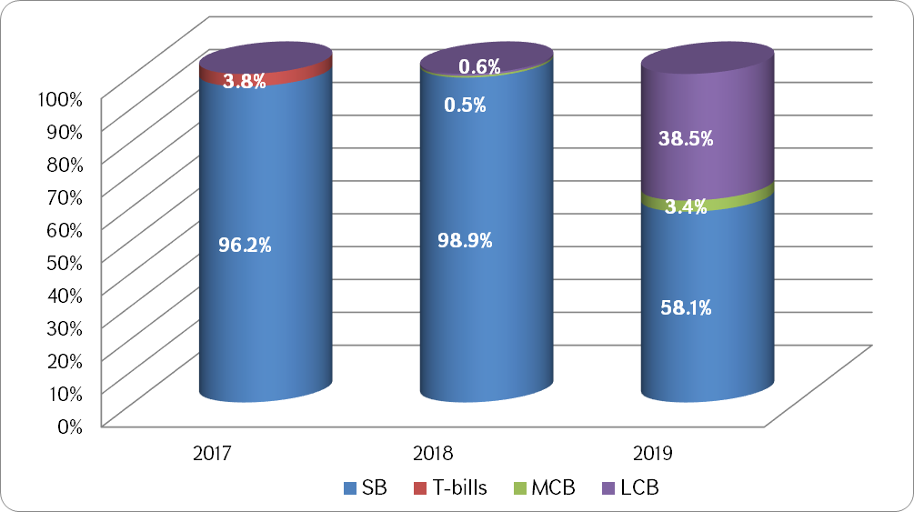

- The volume of investments through the TD online system amounted to AMD 535.2 million, and the volume of investments through the service centers comprised AMD 5,220.5 million,

The volumes of GS allocated through both online and service centers of the Treasure Direct system, million AMD

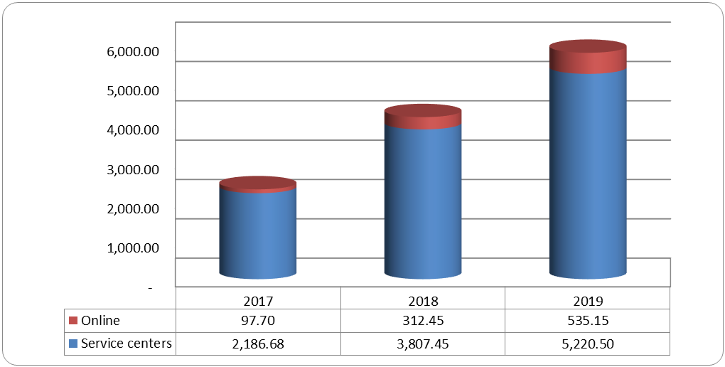

- The volume of investments through the TD online system increased by 41.6% in 2019 compared to the previous year,
- The redemption amount of GS made up AMD 1,981.3 million, of which AMD 0.001 million T-bills and AMD 1,981.3 million SCB, as well as the buyback amount of SCB comprised AMD 371.7 million,
- AMD 2,237.3 million of GS that had been invested through TD system were transferred to other sub-depositories, from which AMD 195.0 million MTCN and AMD 2,042.3 million LTCB,
- As of December 31, 2019, the outstanding amount of GS in TD system made up AMD 6,907.1 million, from which AMD 6,731.8 million SCB and AMD 175.3 million LTCB. The volume of GS allocated through TD system to resident investors made up AMD 6,771.87 million or 98.0% of total investment, the volume of GS allocated through TD system to non-resident investors made up AMD 135.26 million or 2.0% of total investment.

Treasury Direct investors by residency in 2019

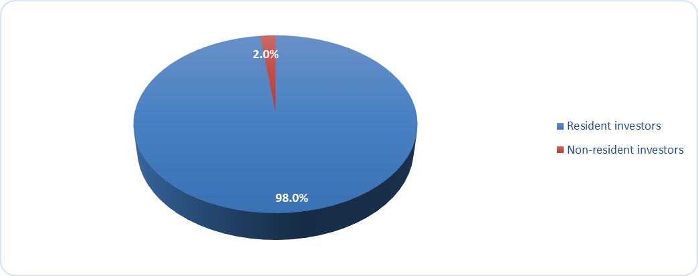

- The number of depository accounts totaled 1661, of which 549 were active depository accounts,
- An average investment amount in the submitted bids made up AMD 6.54 million (for T-bills it made up AMD 0.001 million, for SCB - AMD 8.25 million, for MTCN - AMD 195.0 million and for LTCB - AMD 67.2 million),
- In average 19.6 bids were submitted by TD in one issuance of GS, among which an average 1.0 bid for a T-bills issuance, 20.6 bids for a SCB issuance, 1.0 bid for a MTCB issuance and 16.5 bids for a LTCB issuance,
- The refinancing amount in expense of redeemed GS increased by 21.3% compared to the previous period and made up AMD 1,086.7 million.
- In 2019 the amount of GS invested through the TD system increased by 39.7% over the previous year, of which the investment volume of SCB decreased by 18.0% compared to the previous year and the investment volume of LTCB increased by 98.9%. As of December 31, 2019, the outstanding amount of GS in TD system increased by AMD 1165.4 million or by 20.3% compared to the same indicator in the previous year,

The outstanding amount of GS at the Treasury Direct system in 2019

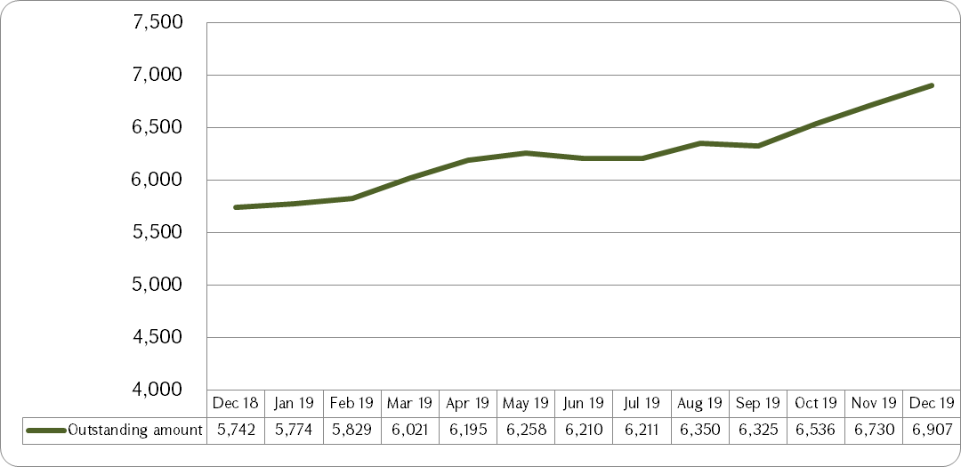

- As of December 31, 2019, the number of depository accounts exceeded the same indicator of the previous year by 146 depository accounts.

The dynamics of depositary accounts in 2019

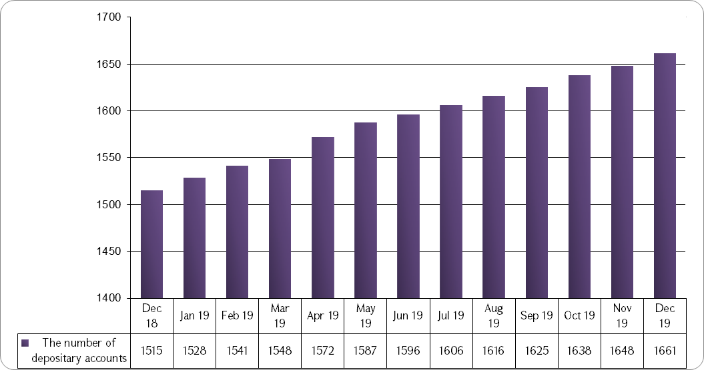

SCB coupon yield is determined based on the yield curve of GS and the average yields of the deposits attracted from individuals by the RA commercial banks.

Foreign Currency Government Bonds
According to the 2020-2022 RA Government debt management strategy that was approved by the RA Government’s decree N 900 on 10th of July 2019, new issuance of Eurobonds was planned in order to refinance the Eurobonds to be matured in 2020.
The RA Government successfully allocated the Eurobonds in the international capital market on 26th September, 2019, which had USD 500 million nominal value and 10-year maturity with 4.2% yield. The coupon rate of newly issued Eurobonds was 3.95%, which was significantly lower than the coupon rate of Eurobonds issued in 2015 (7.150%) and the coupon rate of Eurobonds issued in 2013 (6.0%). If the county risk component was estimated at 551.8 basis points (5.518 percentage points) in the composition of the yield of Eurobonds issued in 2015 with 10-year maturity, then the county risk for newly issued Eurobonds with the same maturity was estimated at 242.8 basis points (2.428 percentage points) by investors. The result reflects the improved international perception of the Republic of Armenia.
This was Armenian third issuance of Eurobonds in the international capital market, the goal of which was the refinancing of Eurobonds to be matured in 2020.

Terms of allocation of the Eurobonds issued in 2019

Issuer | Republic of Armenia
Issuance format | RegS / 144A
Rating | Ba3 (stable) Moody's / B+(positive) Fitch
Allocation amount | 500,000,000 USD
Quotation date | 19 September, 2019
Settlement date | 26 September, 2019
Maturity date | 26 September, 2029
Coupon rate | 3.95%
Allocation price | 97.976
Yield | 4.20%
Benchmark | US bonds (1,625% ) repayable in August, 2029
Spread to 10 year US benchmark | 242.8 basis points
Spread to mid-swap | 255 basis points
Listing | Euronext Dublin (Regulated Market)
Lead Managers | "J.P. Morgan", "Citigroup"

More than 200 investors submitted bids in order to acquire Eurobonds issued in 2019, and the maximum volume of demand amounted to USD 2.8 billion during the allocation period.
The issuance of 10-year Eurobonds in 2019 expanded the geography of allocation and the structure of investors.

The geographical allocation of the Eurobonds issued in 2019

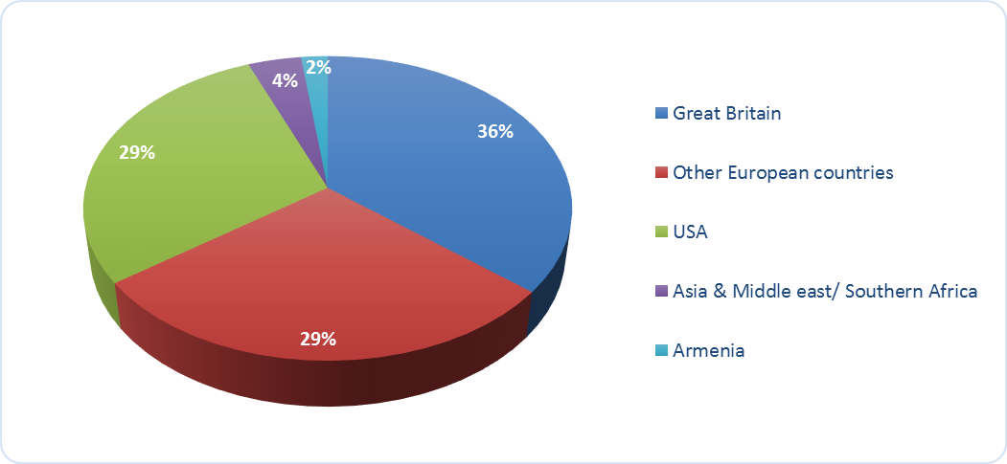

The allocation of the Eurobonds issued in 2019 by investor type

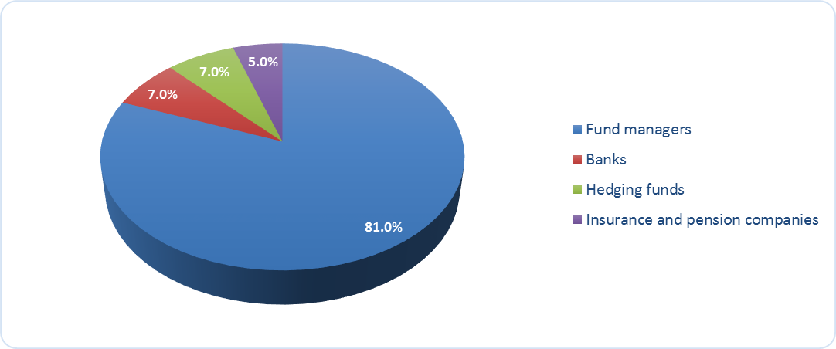

The Republic of Armenia announced the buyback of Eurobonds issued in 2013 (6.0% coupon rate) parallel with the new issuance, as a result of which RA Government channeled funds from the proceeds of the third issuance of Eurobonds to buyback USD 402.4 million or more than 80% of the outstanding amount of the first issuance of Eurobonds on the same day.
As of the December 31, 2019, the outstanding amount of foreign currency Government bonds increased by USD 97.585 million and made up USD 1,097.657 million, from which:
- USD 97.657 million to be matured in 2020 with 6.0% coupon rate,
- USD 500.00 million to be matured in 2025 with 7.15% coupon rate,
- USD 500.00 million to be matured in 2029 with 3.95% coupon rate.
At the end of 2019 11.3% or USD 124.0 million of the outstanding amount of foreign currency Government bonds was in the portfolio of resident investors.
The price spread of Eurobonds issued by the Government of the Republic of Armenia is calculated against US benchmark bonds with the same maturity. Chart 22 shows the yield spread of Eurobonds issued by the Government of Armenia in 2013, 2015 and 2019 and outstanding in 2019 against US benchmark bonds with the same maturity. Although the general trends in the international capital market, in particular the reduction of spreads of foreign currency Government bonds included in EMBI+ index (from 448 basis points at the end of August it reduced to 441 basis points on 23rd September) influenced on the reduction of the yield spread of Eurobonds against US benchmark bonds with the same maturity during 2019, but it was mostly due to the confidence of investors in the policy adopted by the Government of the Republic of Armenia. The latter was evidenced by the issuance results of the countries with higher ratings on the same days. In particular, 10-year bonds of South African Republic (Baa3/BB+ ratings according to Moody’s/Fitch) were allocated with 5.75% on 23rd September, and bonds of Bahrain to be matured in 2031 (BB- rating according to Fitch) were allocated with 5.625% on 24th September. In addition, Moody's raised Armenia's sovereign rating from "B1 positive" to "Ba3 stable" on 27th August, 2019, as a result of the regular revision.

The yield spread of RA Government Eurobonds against USA benchmark securities during 2019 (basis points)

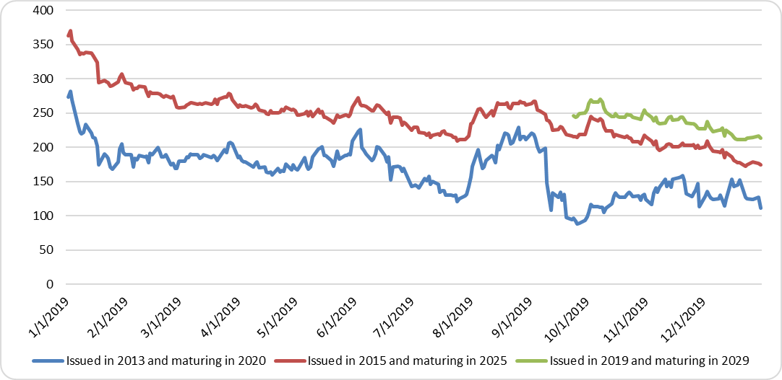
Source՝ Bloomberg

The quotation dynamic of Eurobonds during the reporting year is presented in chart 23.

- The quotation dynamic of Eurobonds issued by RA Government in 2019 (%)

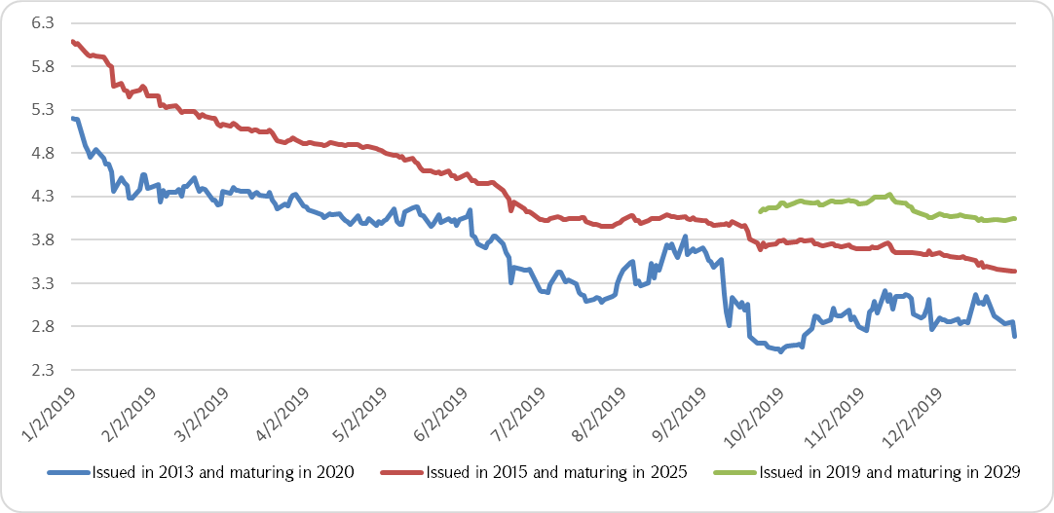
Source՝ Bloomberg

RA Government Loans and Credits
As of December 31, 2019, the RA Government external loans outstanding amount comprised USD 4,309.6 million (AMD 2,067.3 billion) and it increased by USD 170 million or by 4.1% compared to the same indicator as of December 31, 2018.
During 2019 five new loan agreements were signed. The information on agreements is presented in Annex 3.
It was envisaged by 2019 state budget to borrow AMD 240.6 billion (USD 494.4 million) external loans, the actual performance of which made up AMD 173.1 billion (USD 359.2 million) or 72.0% of the planned indicator. Moreover, budget support loans comprised AMD 73.6 billion (USD 151.2 million) almost completely fulfilling the planned indicator, and the project loans amounted to AMD 99.5 billion (USD 208.0 million) or 59.8% of the planned indicator.

Total disbursements during 2019 (billion AMD)

 | Program | Adjusted program | Actual | Performance, % | Actual share, %
Total disbursements | 240.6 | 240.6 | 173.1 | 72.0 | 100
of which
Project loans | 166.5 | 166.5 | 99.5 | 59.8 | 57.5
Budget support loans | 74 | 74 | 73.6 | 99.5 | 42.5

The total amount of disbursements increased by USD 39.5 million or by 12.4% in comparison to the previous year. The disbursements of the loans provided by international organizations increased by USD 22.9 million, and the disbursements of the loans provided by foreign states increased by USD 16.6 million. Moreover, their shares in the total disbursements didn’t change significantly.
95% of the total disbursements was carried out by four creditors: Russian Federation (USD 105.8 million), International Bank for Reconstruction and Development (USD 89.9 million), Asian Development Bank (USD 85.6 million) and Germany (KfW) (USD 60.1 million).

The structure of RA Government loans and credits by creditors as of December 31, 2019

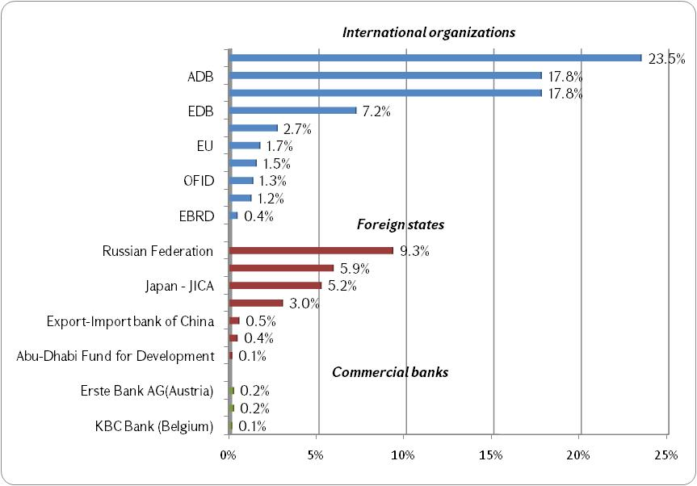

In general, the share of international organizations declined by 1.8 percentage points in the structure of the external creditors. In particular, the share of loans provided by the International Development Association decreased by 2.4 percentage points, the share of loans provided by the International Monetary Fund diminished by 0.7 percentage points, the share of loans provided by the European Investment Bank declined by 0.2 percentage points and the share of loans provided by the Eurasian Development Bank reduced by 0.2 percentage points. Meanwhile, the increase of the shares of some international organizations had been also observed. Hence, the shares of the Asian Development Bank and the International Bank for Reconstruction and Development increased by 0.7 and 1.4 percentage points, respectively, which took place predominantly due to the performed transactions.
The share of foreign states increased by 1.9 percentage points, which was mostly due to the transactions implemented with the loans provided by Russian Federation (increased by 1.7 percentage points) and Germany (KfW) (increased by 0.8 percentage points). The share of Japan (JICA) declined by 0.4 percentage points due to the repayments.
Loans provided by the international organizations prevailed in the structure of the RA Government external loans and credits, the share of which comprised 75.1% at the end of 2019. It should be noted, that the share of the International Development Association from the international organizations is diminishing and will go on decreasing, as Armenia cannot attract loans from that institution anymore due to its level of development and carries out only repayments and services of previously attracted loans. The share of foreign states made up 24.4%, and the share of commercial banks comprised 0.5% at the end of 2019.

The dynamics of the RA Government loans and credits structure by donors

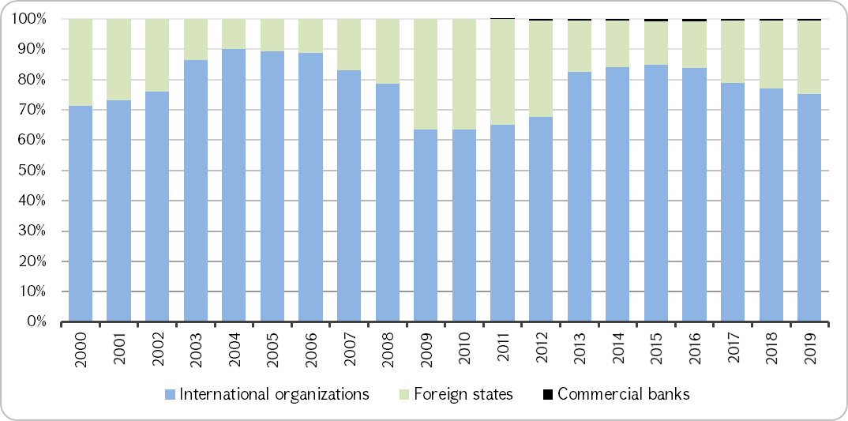

The dynamics of the RA Government loans and credits structure by currency during 1999-2019

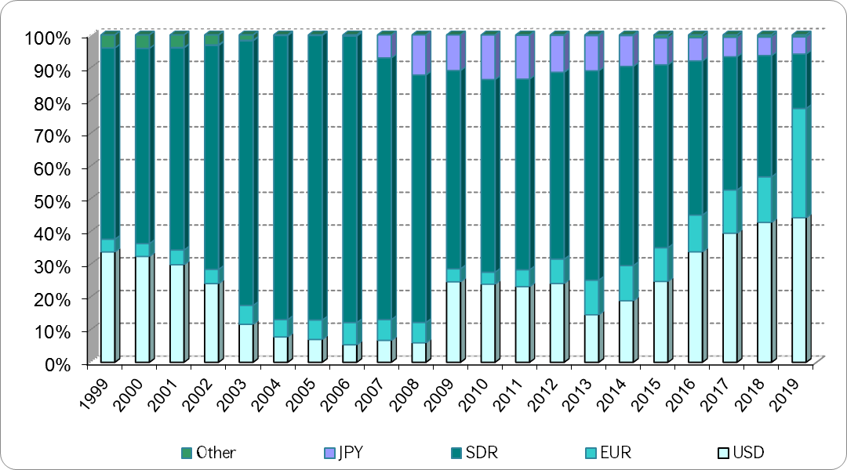

The share of USD and EUR loans increased by 1.4 and 2.7 percentage points, respectively in the structure of the external loans, as the disbursements were mainly fulfilled with the loans denominated in these two currencies (correspondingly 47.9% and 48.4% of total disbursements) in 2019. At the same time, the share of SDR loans declined by 3.7 percentage points and the share of JPY loans diminished by 0.4 percentage points. The reason for the structural changes was also the fact that the main part of the repayments (60.3%) was fulfilled with SDR denominated loans due to the expiration of their grace periods. Meanwhile, the repayments of USD and Euro denominated loans made up 22.7% and 10.7%, respectively.
During 2019, SDR/USD and EUR/USD exchange rates decreased (SDR decreased from 1.39 to 1.38, and EUR declined from 1.14 to 1.12). Thus, if there was no transaction, the debt formulated from the external loans would decrease by USD 18.8 million due to the changes of the exchange rates of the main currencies in the basket against USD.

Dynamics of the average monthly exchange rates of SDR, GBR, EUR and JPY against USD

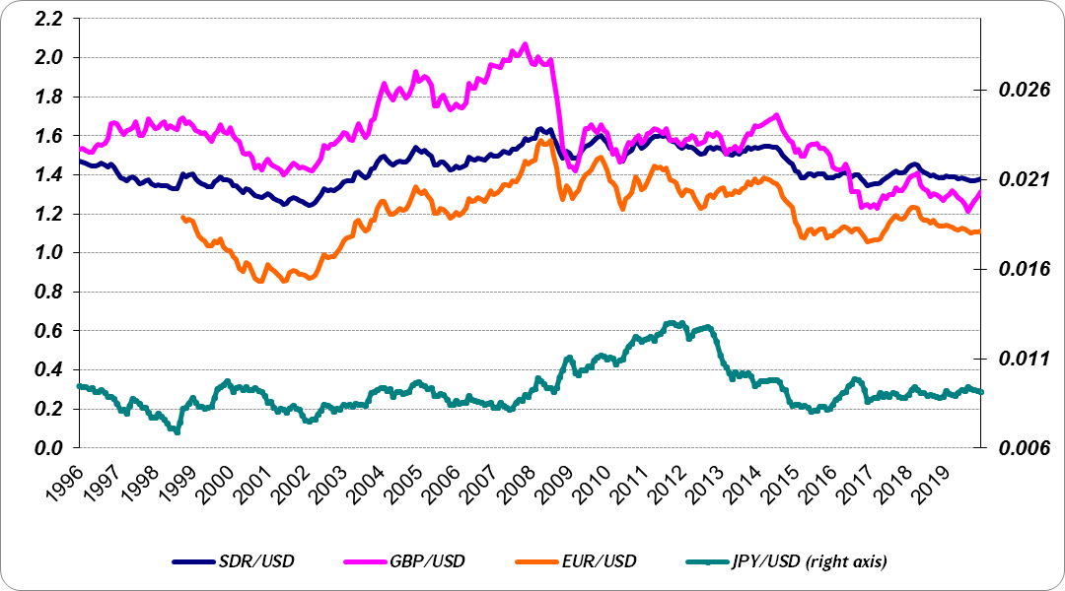
As of the end of 2019, the share of floating rate loans in the structure of RA Government loans and credits comprised 25.6%, which was more by 2.5 percentage points compared to the same indicator in the previous year. In 2019, the share of floating rate loans’ payments made up 9.7% (USD 16.3 million) and the share of fixed rate loans’ payments comprised 90.3% (USD 151.9 million) in the structure of the repayments. 46.1% or USD 165.6 million loan disbursements were with floating rate and 53.9% or USD 193.6 million loan disbursements were with fixed rate in the structure of the loans disbursed by the RA Government during 2019. The loan disbursements with floating rate increased by 3.5 percentage points during 2019 compared to the previous year.

The structure of the RA Government loans and credits by the type of interest rate (1999-2019)

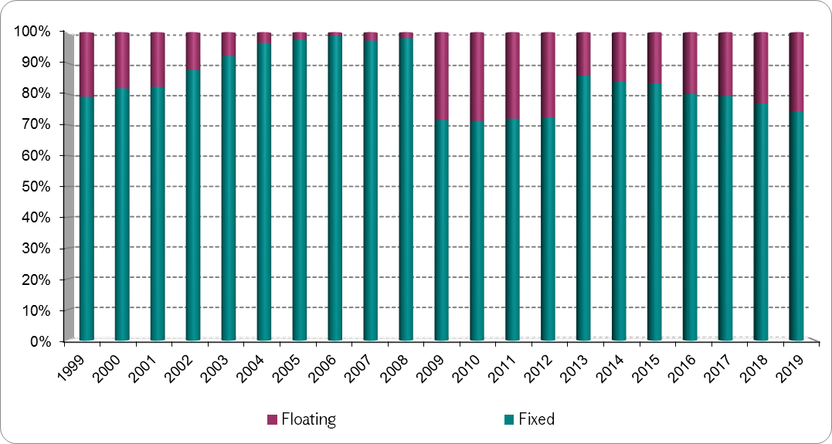
The calculation of the floating interest rate loans is based on the Libor and Euribor interest rates, the behavior of which depends on the existing situation in the international financial market and it is highly volatile.

Dynamics of the average monthly interest rates for 6 months USD Libor and Euribor

As of the end of 2019, the share of commercial loans increased by 4.1 percentage points compared to the previous year comprising 48.4% against 44.3% in 2018.

The dynamics of the concessionality of the RA Government loans and credits (1999-2019)

Information on the transactions carried out with the attracted loans is presented in Annex 4 of this report.

External Debt of the Central Bank of RA
As of 31, December 2019 the external debt of the Central Bank of RA amounted to USD 489.3 million (AMD 234.7 billion) or 3.6% over GDP. The external debt of CBA denominated in USD decreased by 11.8%, and it diminished against GDP by 0.8 percentage points compared to the end of the previous year.
The share of the loans provided with the Guarantee of the RA Government decreased by 0.2 percentage points in the structure of the external debt of CBA and it comprised 25.7% in 2019 against 25.9% in the previous year. The loans provided by the IMF still prevail in the structure of CBA debt and comprise 41.3%, despite 3.9 percentage points decrease in debt structure against the previous year.
- The Structure of the external debt of the Central Bank of RA
 | 31.12.2018 |  | 31.12.2019
 | USD million | % | USD million | %
External Debt of the Central Bank of RA | 550.0 | 100.0 | 489.3 | 100.0
of which
By Creditors
International organizations, of which | 418.4 | 76.1 | 365.1 | 74.6
International Monetary Fund | 248.4 | 45.2 | 202.1 | 41.3
International Bank for Reconstruction and Development | 43.4 | 7.9 | 41.8 | 8.5
Asian Development Bank | 13.8 | 2.5 | 13.7 | 2.8
European Investment Bank | 112.8 | 20.5 | 107.6 | 22.0
Foreign states, of which | 131.7 | 23.9 | 124.2 | 25.4
Germany (KfW) | 131.7 | 23.9 | 124.2 | 25.4
By interest rate type
Fixed interest rate | 297.1 | 54.0 | 275.4 | 56.3
Floating interest rate | 253.0 | 46.0 | 213.9 | 43.7
By currency
SDR | 262.2 | 47.7 | 215.8 | 44.1
USD | 156.2 | 28.4 | 149.3 | 30.5
EUR | 131.7 | 23.9 | 124.2 | 25.4

During 2019 CBA borrowed USD 13.5 million credits from the external sources. Meanwhile, the service payments of the external debt comprised USD 81.6 million, of which USD 11.4 million as interest payments and USD 70.2 million as principal payments.

Cash Flow Management
As of December 31, 2019, the total funds of the treasury single account (TSA and time deposits) amounted to AMD 319.1 billion against AMD 172.8 billion as of December 31, 2018. During the reporting period, the balances of the following sub-accounts of TSA increased significantly: state budget funds (by AMD 62.5 billion), stabilization account funds (by AMD 41.2 billion as a result of Eurobonds transactions in 2019), tax single account (by AMD 21.4 billion) and community budget funds (by AMD 10.2 billion). During 2019 the average daily balance of TSA made up AMD 253.2 billion, of which daily average residual of the time deposits at CBA made up AMD 240.8 billion.
In general, the implementation of the state budget took place within a stable and predictable fiscal environment during the year. The actual tax revenues exceeded the preliminary quarterly proportions approved by the RA Government for all quarters. During the year, the program indicators of the RA state budget were regularly revised increasing revenues and expenditures, and the seasonality of the state budget expenditures didn’t deviate from the seasonality distinctive to the previous years.

Dynamics of the TSA daily residual (without deposits) and total balance dynamics in 2019 (AMD million)

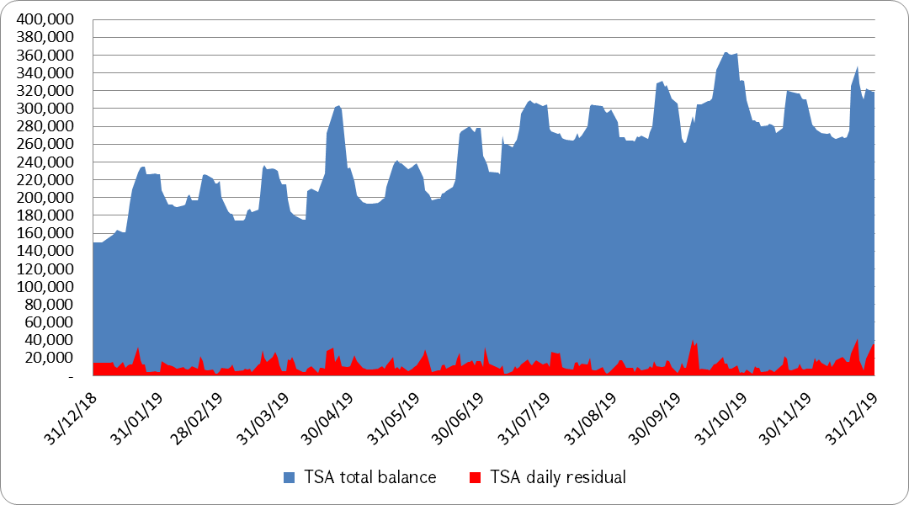

The average residuals of TSA (without deposits) and time deposits (AMD million)

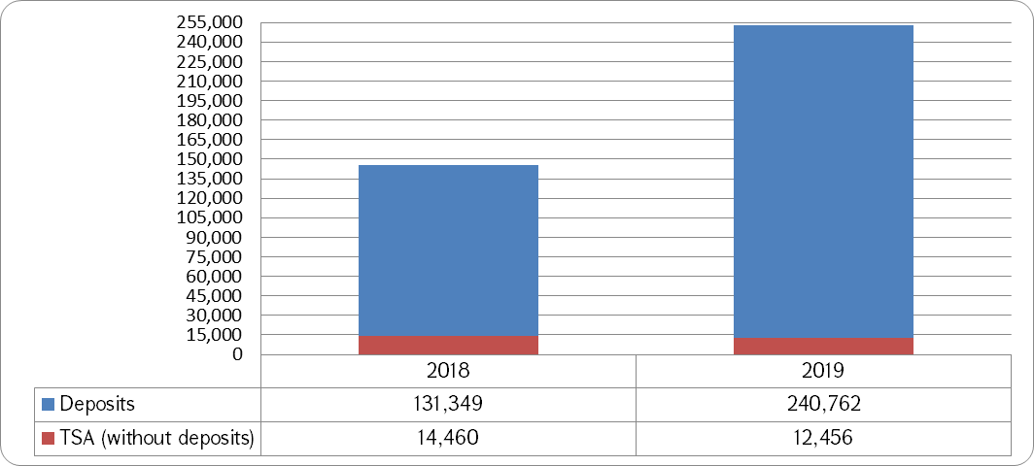
Chart 32 shows that the average balance of TSA (without deposits) was less by AMD 2 billion than the same indicator in the previous year, which means that TSA funds had been more actively managed during 2019. Moreover, the average daily outflows of TSA amounted to AMD 12.0 billion in 2019 compared to AMD 10.7 billion in 2018, which emphasizes more active management of TSA funds during 2019.
The total funds of TSA increased significantly compared to the previous year. This was reflected in the dynamics of the average residual of the time deposits, the latter was higher by AMD 109.4 billion or 83.3% in 2019 compared to the same indicator in the previous year. In 2019 the high average residual of the deposits was due to the fact that the additional free funds were generated during the year as a result of the actual performance of the quarterly proportions indicators of the state budget against the programmed inflow and outflow indicators.

TSA indicators (AMD billion)
 | 2018 | 2019
TSA balance as of December 31 | 172.8 | 319.1
Daily average residual of the time deposits at CBA | 131.3 | 240.8
Income earned from the time deposits invested in CBA | 7.1 | 12.8

During 2019 totally AMD 1,033.0 billion was deposited in the Central Bank of Armenia exceeding the same indicator of the previous year by AMD 150.0 billion. The average maturity of deposits was 83.6 days, which was more by 35.2 days than the same indicator in the previous year.
During 2019 the average interest rate of time deposits was 5.48%. Even though the average interest rate of time deposits was lower by 0.14 percentage points than it had been in the previous year, the revenues received from time deposits increased by AMD 5.7 billion and amounted to AMD 12.8 billion due to the significant increase of the average balance of time deposits in 2019. The above-mentioned favorable conditions allowed exceeding the program indicator of the year by AMD 4.5 billion.

Risks Analysis
In this part of the report it is presented the analysis of the main risks associated with public debt, in particular market (interest rate and exchange rate), re-financing, liquidity and operational risks.
As in the previous years, in 2019 MoF of RA continued the consistent policy of management and decrease of the risks associated with the Government debt management. As a result, the Government debt of RA remained within the manageable level.
As of December 31, 2019 the increase of the RA Government debt comprised 6.4% compared to the previous year, where 4.2 percentage points resulted from the increase of the external debt and the remaining 2.2 percentage points arisen due to the increase of the domestic debt.
As it is known, 2018 was a breakthrough in terms of the growth rate of the debt of the RA Government, when it yielded to the nominal GDP growth rate for the first time since 2013. This trend continued during 2019, and the 6.4% increase in the Government debt was lower by 2.8 percentage points than the 9.2% increase in nominal GDP. The RA Government debt/GDP ratio decreased by 1.3 percentage points compared to the previous year and made up 49.9%. By the way, if the average annual nominal growth of the RA Government debt was 11.8% during the last ten years, then the same indicator totaled only 4.8% during the last two years.

The average annual nominal growth of the RA Government debt

 | 2010 – 2019 | 2018 – 2019
 | Actual | Actual
Average annual nominal growth of the RA Government debt (%) | 11.8 | 4.8

The decrease of the debt burden in 2019 occurred due to the following key factors:
- The Government policy for depletion of the debt in line with fiscal rules, which was expressed by the 2019-2023 RA Government debt reduction revised program,
- The higher economic growth than it was expected, the over-performance of the tax revenue program and the savings in expenditures.
Since 2018, when a new and modernized system of fiscal rules was introduced, the RA Government debt/GDP ratio has been selected as a key target of fiscal policy, aiming at ensuring the stability of the RA Government debt and the gradual reduction of the debt burden (at that time, the Government debt/GDP ratio was exceeding the threshold of 50%). According to the fiscal rules, the RA Government designed and presented in the 2020-2022 MTEF the RA Government debt reduction 2019-2023 revised program, which outlined below 50% indicator (49.7%) for 2023. However, below 50% indicator had already been recorded according to the 2019 data highlighting the earlier implementation of the target, as well as increasing the "fiscal space" and the ability to respond to the economic shocks by involving public debt.
On 10th of July, 2019, the RA Government approved the “2020-2022 Medium Term Expenditure Framework” by the decree N900-N, which includes the 2020-2022 RA Government debt management strategy. The strategy document defined the Government debt planned indicators for 2019 and the forecasted indicators for 2020-2022. The 2020-2022 RA Government debt management strategy defined the following benchmark indicators for the main market risks:

RA Government debt benchmark indicators for 2019-2021

 | Benchmark | 2019  Actual
Refinancing risk
Average time to maturity | 8- 11 years | 9.1 years
The share of up to 1-year maturity bonds in the total GS (at the end of the year) | max 20% | 12.7%
Interest rate risk
The share of fixed rate debt in the total debt | min 80% | 83.8%
Exchange rate risk
The share of domestic debt in the total debt | min 20% | 22.5%
The share of AMD denominated debt in the total debt | min 20% | 20.8%

As it is seen from table, all benchmark indicators set by the 2020-2022 RA Government debt management strategy were within the specified ranges as a result of the RA Government debt management.

Interest Rate Risk
In table 17, the RA Government debt interest payments/GDP actual indicator is presented in the comparison to the indicators approved by 2019 state budget and envisaged by the 2020-2022 RA Government Debt Management Strategy.

RA Government debt interest payments

 | 2018 | 2019 | 2019
 | Actual | Program | Actual
Interest payments/GDP (%) | 2.3 | 2.3 | 2.4

The actual interest payments as a share of GDP increased by 0.1 percentage points compared to the actual indicators of the previous year and the indicators envisaged by the 2020-2022 RA Government debt management strategy. The growth of nominal interest payments totaled 13.3% compared to the previous year, which was the lowest increase in the last ten years.
The reasons of the increase in RA Government debt service are described in the "RA Government Debt Service" section.

GS primary allocation yields, (%)

 | 2018 | 2019
 | Actual | Actual
Weighted average yields of GS allocated in the current year | 8.85 | 8.97
Of which
T-bills | 6.13 | 5.92
MTCN | 8.02 | 7.74
LTCB | 10.96 | 10.43

The weighted average interest rate of GS allocated during 2019 increased by 0.12 percentage points compared to the previous year.
The restriction of the growth of loans with floating interest rates was highlighted in the perspective of the interest rate risk management.

The shares of RA Government fixed and floating rate debt, (%)

 | 2018 | 2019 | 2019
Interest rate | Actual | Forecast | Actual
Fixed | 85.0 | 82.6 | 83.8
Floating | 15.0 | 17.4 | 16.2

In the 2020-2022 RA Government debt management strategy the target shares of the floating and fixed interest rates of the existing debt for the end of 2019 were determined to be 17.4 and 82.6, respectively. The Government managed to increase the share of fixed rate liabilities by 1.2 percentage points in comparison to the planned indicator, however the actual indicator decreased by 1.2 percentage points compared to the same indicator in the previous year mainly due to the structure of the transactions with external loans.

Interest rate risk indicators of RA Government debt in 2019

 | 2019 | 2019
 | Forecast | Actual
Average time to refixing of the RA Government debt (year) | 6.3 | 7.5
Average time to refixing of the external debt (year) | 6.1 | 6.9
Average time to refixing of the domestic debt (year) | 7.3 | 9.8
The share of the RA Government debt refixing during a year (%) | 30.2 | 22.8
The share of the external debt refixing during a year (%) | 33.2 | 24.9
The share of the domestic debt refixing during a year (%) | 19.3 | 15.5

All interest rate risk indicators reflected in table 20 had positive trends compared to the forecasted levels as a result of the RA Government debt management.

Exchange Rate Risk
To reduce the exchange rate risk, MoF of RA signed an agreement with CBA in 2007, according to which during the budgeting year all foreign currency inflow and outflow transactions of the Government debt payments should be converted based on the exchange rates that are applied in the RA Government budget message and are used for the calculation of the current RA Government state budget law (if the budget is not in force, then the draft of the budget) indicators. This agreement provided an opportunity to the Government to fix exchange rates on foreign currency debt payments over the year, hedging the exchange rate risk and making it more manageable.
The monthly average exchange rates of AMD against USD and EUR for 2019 are presented in Chart 33.

AMD exchange rate against USD and EUR in 2019

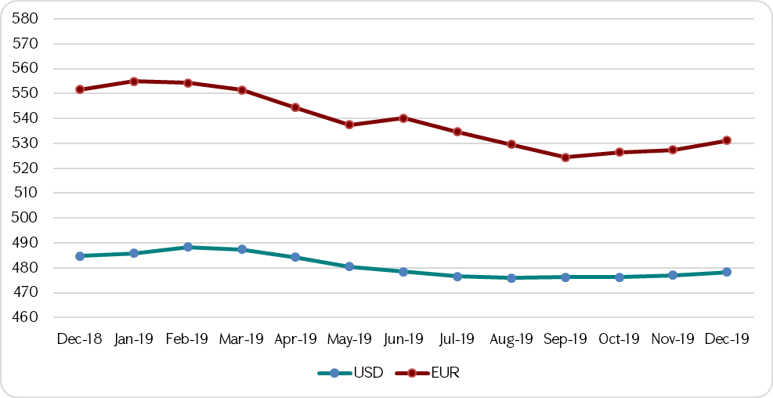
During 2019 USD/AMD exchange rate did not fluctuate much, but EUR/AMD exchange rate was more volatile.

RA Government external debt

 | 2018 | 2019 | Change (%)
RA Government external debt (AMD billion) | 2,412.1 | 2,541.5 | 5.4%
RA Government external debt (USD million) | 4,986.3 | 5,298.1 | 6.3%
USD exchange rate at the end of the year | 483.75 | 479.7 | (0.8)%
As of the end of 2019, the RA Government external debt increased both in USD and AMD.

RA Government debt currency structure (%)
 | 2018 | 2019
 | Actual | Actual
Currency structure | 100.0 | 100.0
of which
Debt denominated in AMD | 19.1 | 20.8
Debt denominated in foreign currency | 80.9 | 79.2
of which
USD | 43.6 | 43.9
SDR | 24.1 | 21.0
EUR | 9.2 | 10.6
JPY | 3.7 | 3.3
AED | 0.1 | 0.1
CNY | 0.4 | 0.3

The share of debt denominated in AMD increased by 1.7 percentage points in the currency structure of the RA Government debt due to the growth of GS share in the structure of the RA state budget deficit. The shares of USD denominated debt and euro denominated debt increased by 0.3 and 1.4 percentage points, respectively in the currency structure of the RA Government debt, but the shares of SDR and Yen debt denominated debts decreased by 3.0 and 0.4 percentage points, respectively due to the nature of the external loan transactions during the year.

Refinancing Risk
Refinancing risk is being assessed by the smoothness of the repayment profile of the outstanding debt (which means that there aren’t any heavy periods in meeting debt redemption obligations), by the Average Time to Maturity (ATM), the share of short-term debt in overall debt portfolio and some other risk indicators.

Government debt redemption schedule in 2019 (AMD million)

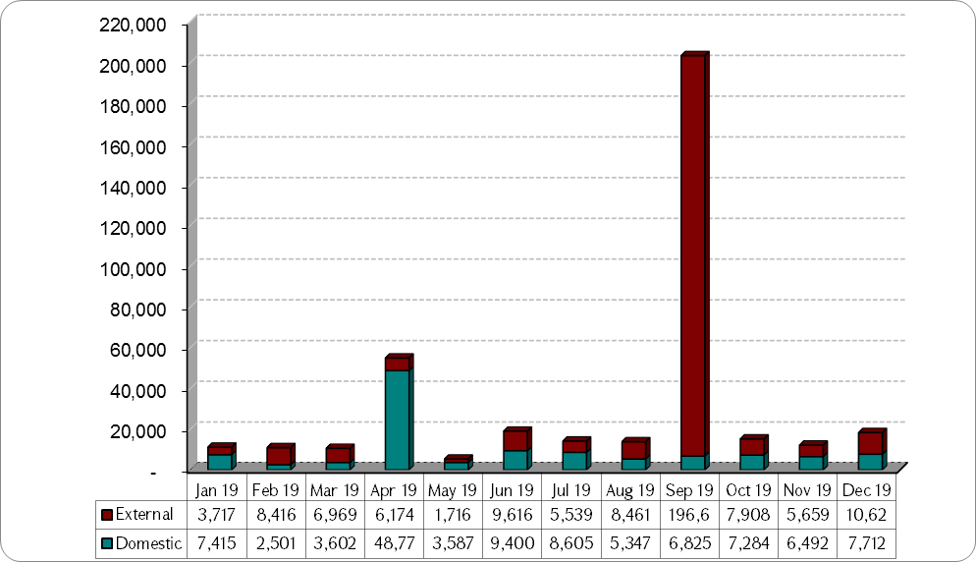
The Government debt redemption profile in 2019 shows that the significant share of monthly repayments in 2019 was concentrated in September. The latter was due to buyback of USD 402.4 million Eurobonds repayable in 2020.
In 2019 the second largest redemption of the RA Government debt was concentrated in April, because the repayments are being concentrated on the specific days in order to increase the liquidity of the bonds according to the international best practice. Thus, on 29th of April, the redemptions of 3-year and 5-year maturity benchmark bonds amounted to AMD 34.2 billion and AMD 11.1 billion, respectively.

RA Government debt structure by weighted average time to maturity
 | 2018 | 2019
 | Actual | Actual
The structure by weighted average time to maturity, % | 100.0 | 100.0
of which
Short-term (up to 1 year) | 2.6 | 4.4
Medium-term (1-5 years) | 22.7 | 16.4
Long-term (more than 5 years) | 74.6 | 79.2

Table 23 shows that the share of medium-term debt in the structure of the RA Government debt decreased by 6.3 percentage points, the shares of short-term and long-term debts in the structure of the RA Government debt increased by 1.8 and 4.6 percentage points, respectively.
The comparison of the main indicators of GS with the previous year is presented below.

The indicators of outstanding GS
 | 2018 | 2019
Average time to maturity (year) | 9.1 | 10.2
The share of GS maturing in the forthcoming year in the total GS (%) | 12.9 | 12.7

The indicators of the outstanding GS improved in comparison to the previous year diminishing the refinancing risk.
As of the end of 2019 the repayments of the Government external loans were extended up to 2054, the repayments of AMD denominated bonds were spread up to 2047, the repayments of foreign currency securities were extended up to 2029, and the repayments of the guarantees were up to 2036.

Government debt maturity profile as of December 31, 2019 (AMD billion)
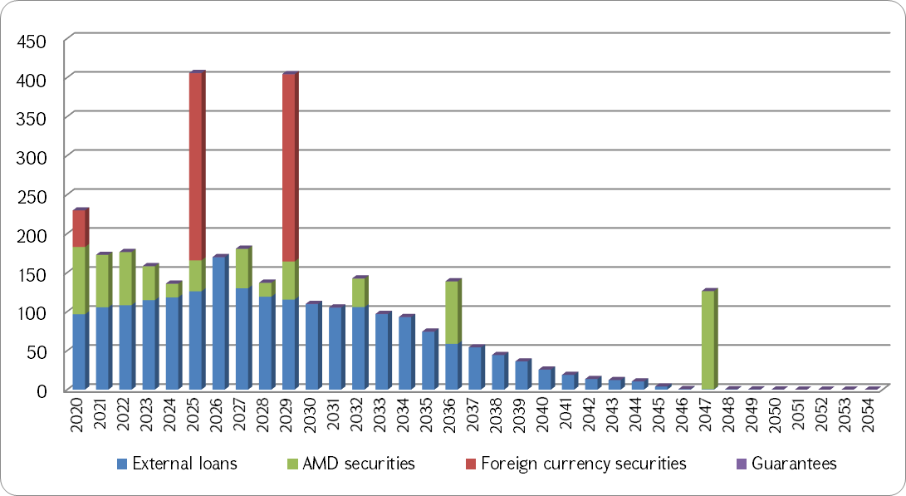
As at the end of 2019, the large repayment years are 2025 and 2029 in the RA Government debt maturity profile. 59.1% of the Government debt redemption in 2025 consists of the redemption of 10-year maturity Eurobonds issued in 2015, and 59.3% of the Government debt redemption in 2029 consists of the redemption of 10-year maturity Eurobonds issued in 2019.
RA Government defined the following refinancing risk targeted indicators in the 2020-2022 RA Government debt management strategy program:

RA Government debt refinancing risk indicators in 2019

 | 2019 | 2019
 | Forecast | Actual
RA Government debt average time to maturity (year) | 8.1 | 9.1
External debt ATM (year) | 8.3 | 8.9
Domestic debt ATM (year) | 7.3 | 9.8
RA Government debt maturing within one year (%) | 13.3 | 7.0
Share of RA Government external debt maturing within one year (%) | 11.6 | 4.6
Share of RA Government domestic debt maturing within one year (%) | 19.3 | 15.5

A study of table 25 shows that all refinancing risk indicators were significantly improved compared to the forecasted levels. It was mainly due to the fact that the transactions of the buyback of Eurobonds maturing in 2020 and issuance of new Eurobonds maturing in 2029 had a very positive impact on the refinancing risk indicators of both the RA Government debt and the RA Government external debt, as well as on the refinancing risk indicators of the RA Government domestic debt, as the domestic debt represents the sum of the incurred and existing debt obligations to the residents of the Republic of Armenia on the basis of borrowing or credit agreements, and the RA residents also took part in the above-mentioned transactions. The refinancing risk indicators of the RA Government domestic debt showed a positive trend also due to the increase of the long-term bonds share in the domestic debt.
The actual data of the all above mentioned indicators evidence that the refinancing risk was within the manageable scope with the 2019 outcomes.

Operational Risk
The RA Ministry of Finance continually reveals, assesses, manages and decreases the operational risks related to the RA Government debt management.
The Public Debt Management Department continuously registers, researches and offers solutions to identified problems based on the documents "Operational Risk Management Framework" and "Business Continuity Plan" for the Public Debt Management Department at the Ministry of Finance of RA adopted by 17th of September, 2018, N 445 order of the Minister of Finance.
The operational risk management framework includes:
- Perception and documentation of the main business processes,
- Identification, assessment and measurement of the operational risks,
- Development of the risk management document in order to prevent, mitigate or suspend operational risks,
- Implementation of the risk management strategies,
- Performance monitoring by each section,
- Continuous improvement of the operational risk management,
- Ensuring the accountability of operational risks.
Through the “Business Continuity Plan” PDMD at MoF of RA manages those operational risks that could endanger or harm the implementation of the activities of the RA Government debt management.
During 2019 each member of the staff of PDMD at MoF of RA monitored operational risks related to his activities and in case of accidents recorded them. Statistics on the operational risk were summarized, the recorded risks were discussed and appropriate solutions were provided on a quarterly basis.

Government treasury securities transactions in 2019
In 2019 Government issued new securities, in particular: 1-year T-bills, 3 and 5-year maturity MTCN, as well as 10-year and 30-year maturity LTCB. During the year the allocation amounts of GS comprised (without the volume intended for free sale by TD): up to 1 year T-bills - AMD 36.6 billion, by issuance maturity 3-year and 5-year MTCN - AMD 18.0 billion and AMD 34.0 billion, respectively, by issuance maturity 10-year and 30-year LTCB – AMD 66.0 billion and AMD 54.0 billion, respectively. In 2019 the volume of market bonds being allocated also through TD was set up 10% of the allocation volume of each allocation auction.

Table 1.1. Transactions of marketable GS during 2019

 | T-bills | MTCN | LTCB | Total
Number of allocation auctions (quantity) | 34 | 8 | 4 | 46
Number of additional allocations (quantity) | 13 | 3 | 3 | 19
Amount available to be allocated (excluding the amount of available to be allocated by Treasury Direct) (AMD billion) | 36.6 | 52.0 | 120.0 | 208.6
Total allocated amount (AMD billion), of which | 35.9 | 51.9 | 118.7 | 206.5
By primary dealers (AMD billion) | 35.9 | 51.7 | 116.5 | 204.1
By Treasury Direct system (direct sale) (AMD billion) | 0.000001 | 0.195 | 2.2176 | 2.4126
The share in the total allocated amount | 17.4% | 25.1% | 57.5% | 100%
The average allocated amount by primary dealers (AMD billion) | 0.8 | 4.7 | 16.6 | 3.1

- The demand for GS totaled AMD 428.3 billion and it exceeded the allocation amount by more than 2 times,
- The weighted average yield of allocations comprised 8.97%,
- The maximum allocation maturity made up 28 years during the reopening of 30-year original maturity LTCB, and the minimum maturity was 14 weeks according to the reopening of 52-week original maturity T-bills.
During 2019 MoF of RA carried out buybacks of GS with the total amount of AMD 28.2 billion.
During the reporting period 41 issues of SCB took place with the total amount of AMD 11.5 billion, of which AMD 3.34 billion was allocated.

Table 1.2. The data of GS auctions took place during 2019
Allocation date |  | ISIN |  | Available amount for allocation (AMD million) |  |  |  |  |  |  |  |  |  | Allocation type |  |  |  |  |  |  |  |  | Demand  (AMD million) |  |  |  |  |  |  |  |  | Allocation  (AMD million) |  |  |  |  |  |  |  | Minimum yield (%) |  |  |  |  |  |  |  |  |  | Marginal yield (%) |  |  |  |  |  |  |  |  |  | Weighted average yield (%) |  |  |  |  |  |  |  |  |  | Redemption date
15/JAN/2019 |  | AMGT52131209 |  |  |  |  |  |  |  |  |  | 1,000 |  |  |  |  |  |  |  | Auction | 1,700 |  |  |  |  |  |  |  |  | 1,000 |  |  |  |  |  |  |  |  |  |  |  |  |  |  |  |  | 6.1499 |  |  |  |  |  |  |  |  |  | 6.2533 |  |  |  |  |  | 6.2258 |  |  |  |  | 13/JAN/2020
15/JAN/2019 |  | AMGT52131209 |  |  |  |  |  |  |  |  |  | 200 |  |  |  |  |  |  |  | Additional auction | 100 |  |  |  |  |  |  |  |  | 100 |  |  |  |  |  |  |  |  |  |  |  |  |  |  |  |  | 6.2258 |  |  |  |  |  |  |  |  |  | 6.2258 |  |  |  |  |  | 6.2258 |  |  |  |  | 13/JAN/2020
16/JAN/2019 |  | AMGB1029A276 |  |  |  |  |  |  |  |  |  | 15,000 |  |  |  |  |  |  |  | Auction | 15,621 |  |  |  |  |  |  |  |  | 15,000 |  |  |  |  |  |  |  |  |  |  |  |  |  |  |  |  | 9.2497 |  |  |  |  |  |  |  |  |  | 10.7111 |  |  |  |  |  | 9.7418 |  |  |  |  | 29/OCT/2027
16/JAN/2019 |  | AMGB1029A276 |  |  |  |  |  |  |  |  |  | 3,000 |  |  |  |  |  |  |  | Additional auction | 150 |  |  |  |  |  |  |  |  | 150 |  |  |  |  |  |  |  |  |  |  |  |  |  |  |  |  | 9.7418 |  |  |  |  |  |  |  |  |  | 9.7418 |  |  |  |  |  | 9.7418 |  |  |  |  | 29/OCT/2027
22/JAN/2019 |  | AMGT52017192 |  |  |  |  |  |  |  |  |  | 1,000 |  |  |  |  |  |  |  | Auction | 1,260 |  |  |  |  |  |  |  |  | 1,000 |  |  |  |  |  |  |  |  |  |  |  |  |  |  |  |  | 6.2214 |  |  |  |  |  |  |  |  |  | 6.2214 |  |  |  |  |  | 6.2214 |  |  |  |  | 1/JUL/2019
22/JAN/2019 |  | AMGT52017192 |  |  |  |  |  |  |  |  |  | 200 |  |  |  |  |  |  |  | Additional auction | 12 |  |  |  |  |  |  |  |  | 12 |  |  |  |  |  |  |  |  |  |  |  |  |  |  |  |  | 6.2214 |  |  |  |  |  |  |  |  |  | 6.2214 |  |  |  |  |  | 6.2214 |  |  |  |  | 1/JUL/2019
Total January |  |  |  | 20,400 |  |  |  |  |  |  |  |  |  |  |  |  |  |  |  |  |  |  | 18,843 |  |  |  |  |  |  |  |  | 17,262 |  |  |  |  |  |  |  |  |  |  |  |  |  |  |  |  |  |  |  |  |  |  |  |  |  |  |  | 9.3114
5/FEB/2019 |  | AMGT52032209 |  |  | 1,000 |  |  |  |  |  |  |  |  |  | Auction |  |  |  |  |  |  |  |  | 1,410 |  |  |  |  |  |  |  |  | 1,000 |  |  |  |  |  |  |  | 6.1984 |  |  |  |  |  |  |  |  |  | 6.3397 |  |  |  |  |  |  |  |  |  | 6.2497 |  |  |  |  |  |  |  |  |  | 3/FEB/2020
5/FEB/2019 |  | AMGT52032209 |  |  | 200 |  |  |  |  |  |  |  |  |  | Additional auction |  |  |  |  |  |  |  |  | - |  |  |  |  |  |  |  |  | - |  |  |  |  |  |  |  | - |  |  |  |  |  |  |  |  |  | - |  |  |  |  |  |  |  |  |  | - |  |  |  |  |  |  |  |  |  | 3/FEB/2020
13/FEB/2019 |  | AMGN60294235 |  |  | 7,000 |  |  |  |  |  |  |  |  |  | Auction |  |  |  |  |  |  |  |  | 12,550 |  |  |  |  |  |  |  |  | 7,000 |  |  |  |  |  |  |  | 8.3453 |  |  |  |  |  |  |  |  |  | 8.6715 |  |  |  |  |  |  |  |  |  | 8.5092 |  |  |  |  |  |  |  |  |  | 29/APR/2023
13/FEB/2019 |  | AMGN60294235 |  |  | 1,400 |  |  |  |  |  |  |  |  |  | Additional auction |  |  |  |  |  |  |  |  | 1,390 |  |  |  |  |  |  |  |  | 1,390 |  |  |  |  |  |  |  | 8.5092 |  |  |  |  |  |  |  |  |  | 8.5092 |  |  |  |  |  |  |  |  |  | 8.5092 |  |  |  |  |  |  |  |  |  | 29/APR/2023
19/FEB/2019 |  | AMGT5204B198 |  |  | 1,000 |  |  |  |  |  |  |  |  |  | Auction |  |  |  |  |  |  |  |  | 1,410 |  |  |  |  |  |  |  |  | 1,000 |  |  |  |  |  |  |  | 6.0997 |  |  |  |  |  |  |  |  |  | 6.1557 |  |  |  |  |  |  |  |  |  | 6.1296 |  |  |  |  |  |  |  |  |  | 4/NOV/2019
19/FEB/2019 |  | AMGT5204B198 |  |  | 200 |  |  |  |  |  |  |  |  |  | Additional auction |  |  |  |  |  |  |  |  | 200 |  |  |  |  |  |  |  |  | 200 |  |  |  |  |  |  |  | 6.1296 |  |  |  |  |  |  |  |  |  | 6.1296 |  |  |  |  |  |  |  |  |  | 6.1296 |  |  |  |  |  |  |  |  |  | 4/NOV/2019
26/FEB/2019 |  | AMGT52036192 |  |  | 1,000 |  |  |  |  |  |  |  |  |  | Auction |  |  |  |  |  |  |  |  | 1,210 |  |  |  |  |  |  |  |  | 1,000 |  |  |  |  |  |  |  | 5.8450 |  |  |  |  |  |  |  |  |  | 6.1025 |  |  |  |  |  |  |  |  |  | 6.0762 |  |  |  |  |  |  |  |  |  | 3/JUN/2019
26/FEB/2019 |  | AMGT52036192 |  |  | 200 |  |  |  |  |  |  |  |  |  | Additional auction |  |  |  |  |  |  |  |  | 198 |  |  |  |  |  |  |  |  | 198 |  |  |  |  |  |  |  | 6.0762 |  |  |  |  |  |  |  |  |  | 6.0762 |  |  |  |  |  |  |  |  |  | 6.0762 |  |  |  |  |  |  |  |  |  | 3/JUN/2019
Total February |  |  |  | 12,000 |  |  |  |  |  |  |  |  |  |  |  |  |  |  |  |  |  |  | 18,368 |  |  |  |  |  |  |  |  | 11,788 |  |  |  |  |  |  |  |  |  |  |  |  |  |  |  |  |  |  |  |  |  |  |  |  |  |  |  | 7.8280
5/MAR/2019 |  | AMGT52023208 |  |  |  |  | 1,000 |  |  |  |  |  |  |  |  |  | Auction |  |  |  |  |  |  |  |  | 1,410 |  |  |  |  |  |  |  |  | 1,000 |  |  |  |  |  |  |  | 6.1497 |  |  |  |  |  |  |  |  |  | 6.2127 |  |  |  |  |  |  |  |  |  | 6.1812 |  |  |  |  |  |  |  |  |  | 2/MAR/2020
5/MAR/2019 |  | AMGT52023208 |  |  |  |  | 200 |  |  |  |  |  |  |  |  |  | Additional auction |  |  |  |  |  |  |  |  | 200 |  |  |  |  |  |  |  |  | 200 |  |  |  |  |  |  |  | 6.1812 |  |  |  |  |  |  |  |  |  | 6.1812 |  |  |  |  |  |  |  |  |  | 6.1812 |  |  |  |  |  |  |  |  |  | 2/MAR/2020
13/MAR/2019 |  | AMGN60294227 |  |  |  |  | 7,000 |  |  |  |  |  |  |  |  |  | Auction |  |  |  |  |  |  |  |  | 10,748 |  |  |  |  |  |  |  |  | 7,000 |  |  |  |  |  |  |  | 7.9510 |  |  |  |  |  |  |  |  |  | 8.2882 |  |  |  |  |  |  |  |  |  | 8.1738 |  |  |  |  |  |  |  |  |  | 29/APR/2022
13/MAR/2019 |  | AMGN60294227 |  |  |  |  | 1,400 |  |  |  |  |  |  |  |  |  | Additional auction |  |  |  |  |  |  |  |  | 1,162.4 |  |  |  |  |  |  |  |  | 1,162.4 |  |  |  |  |  |  |  | 8.1738 |  |  |  |  |  |  |  |  |  | 8.1738 |  |  |  |  |  |  |  |  |  | 8.1738 |  |  |  |  |  |  |  |  |  | 29/APR/2022
19/MAR/2019 |  | AMGT5202C190 |  |  |  |  | 1,000 |  |  |  |  |  |  |  |  |  | Auction |  |  |  |  |  |  |  |  | 2,650 |  |  |  |  |  |  |  |  | 1,000 |  |  |  |  |  |  |  | 6.0400 |  |  |  |  |  |  |  |  |  | 6.1067 |  |  |  |  |  |  |  |  |  | 6.0791 |  |  |  |  |  |  |  |  |  | 2/DEC/2019
19/MAR/2019 |  | AMGT5202C190 |  |  |  |  | 200 |  |  |  |  |  |  |  |  |  | Additional auction |  |  |  |  |  |  |  |  | 180 |  |  |  |  |  |  |  |  | 180 |  |  |  |  |  |  |  | 6.0791 |  |  |  |  |  |  |  |  |  | 6.0791 |  |  |  |  |  |  |  |  |  | 6.0791 |  |  |  |  |  |  |  |  |  | 2/DEC/2019
26/MAR/2019 |  | AMGT52309193 |  |  |  |  | 1,000 |  |  |  |  |  |  |  |  |  | Auction |  |  |  |  |  |  |  |  | 1,720 |  |  |  |  |  |  |  |  | 1,000 |  |  |  |  |  |  |  | 5.9800 |  |  |  |  |  |  |  |  |  | 6.0777 |  |  |  |  |  |  |  |  |  | 6.0307 |  |  |  |  |  |  |  |  |  | 30/SEP/2019
26/MAR/2019 |  | AMGT52309193 |  |  |  |  | 200 |  |  |  |  |  |  |  |  |  | Additional auction |  |  |  |  |  |  |  |  | 96 |  |  |  |  |  |  |  |  | 96 |  |  |  |  |  |  |  | 6.0307 |  |  |  |  |  |  |  |  |  | 6.0307 |  |  |  |  |  |  |  |  |  | 6.0307 |  |  |  |  |  |  |  |  |  | 30/SEP/2019
Total March |  |  |  | 12,000 |  |  |  |  |  |  |  |  |  |  |  |  |  |  |  |  |  |  | 18,166.4 |  |  |  |  |  |  |  |  | 11,638.4 |  |  |  |  |  |  |  |  |  |  |  |  |  |  |  |  |  |  |  |  |  |  |  |  |  |  |  | 7.5542
Total I quarter |  |  |  | 44,400 |  |  |  |  |  |  |  |  |  |  |  |  |  |  |  |  |  |  | 55,377.4 |  |  |  |  |  |  |  |  | 40,688.4
2/APR/2019 |  | AMGT52303204 |  |  |  |  |  | 1,000 |  |  |  |  |  |  |  |  |  | Auction |  |  |  |  |  |  |  |  | 1,610 |  |  |  |  |  |  |  |  | 1,000 |  |  |  |  |  |  |  | 6.1497 |  |  |  |  |  |  |  |  |  | 6.1987 |  |  |  |  |  |  |  |  |  | 6.1742 |  |  |  |  |  |  |  |  |  | 30/MAR/2020
2/APR/2019 |  | AMGT52303204 |  |  |  |  |  | 200 |  |  |  |  |  |  |  |  |  | Additional auction |  |  |  |  |  |  |  |  | 200 |  |  |  |  |  |  |  |  | 200 |  |  |  |  |  |  |  | 6.1742 |  |  |  |  |  |  |  |  |  | 6.1742 |  |  |  |  |  |  |  |  |  | 6.1742 |  |  |  |  |  |  |  |  |  | 30/MAR/2020
10/APR/2019 |  | AMGB30163472 |  |  |  |  |  | 25,000 |  |  |  |  |  |  |  |  |  | Auction |  |  |  |  |  |  |  |  | 46,170.17 |  |  |  |  |  |  |  |  | 25,000 |  |  |  |  |  |  |  | 11.1790 |  |  |  |  |  |  |  |  |  | 11.6874 |  |  |  |  |  |  |  |  |  | 11.6442 |  |  |  |  |  |  |  |  |  | 16/ MAR/2047
10/APR/2019 |  | AMGB30163472 |  |  |  |  |  | 5,000 |  |  |  |  |  |  |  |  |  | Additional auction |  |  |  |  |  |  |  |  | 4,415.3 |  |  |  |  |  |  |  |  | 4,415.3 |  |  |  |  |  |  |  | 11.6442 |  |  |  |  |  |  |  |  |  | 11.6442 |  |  |  |  |  |  |  |  |  | 11.6442 |  |  |  |  |  |  |  |  |  | 16/ MAR/2047
10/APR/2019 |  | AMGB30163472 |  |  |  |  |  | 2,500 |  |  |  |  |  |  |  |  |  | Direct sale |  |  |  |  |  |  |  |  | 75.94 |  |  |  |  |  |  |  |  | 75.94 |  |  |  |  |  |  |  | 11.6442 |  |  |  |  |  |  |  |  |  | 11.6442 |  |  |  |  |  |  |  |  |  | 11.6442 |  |  |  |  |  |  |  |  |  | 16/ MAR/2047
16/APR/2019 |  | AMGT52309193 |  |  |  |  |  | 1,000 |  |  |  |  |  |  |  |  |  | Auction |  |  |  |  |  |  |  |  | 2,310 |  |  |  |  |  |  |  |  | 1,000 |  |  |  |  |  |  |  | 5.9399 |  |  |  |  |  |  |  |  |  | 6.0000 |  |  |  |  |  |  |  |  |  | 5.9913 |  |  |  |  |  |  |  |  |  | 30/SEP/2019
16/APR/2019 |  | AMGT52309193 |  |  |  |  |  | 200 |  |  |  |  |  |  |  |  |  | Additional auction |  |  |  |  |  |  |  |  | 200 |  |  |  |  |  |  |  |  | 200 |  |  |  |  |  |  |  | 5.9913 |  |  |  |  |  |  |  |  |  | 5.9913 |  |  |  |  |  |  |  |  |  | 5.9913 |  |  |  |  |  |  |  |  |  | 30/SEP/2019
30/APR/2019 |  | AMGT52058196 |  |  |  |  |  | 1,000 |  |  |  |  |  |  |  |  |  | Auction |  |  |  |  |  |  |  |  | 2,710 |  |  |  |  |  |  |  |  | 1,000 |  |  |  |  |  |  |  | 5.7990 |  |  |  |  |  |  |  |  |  | 5.8997 |  |  |  |  |  |  |  |  |  | 5.8206 |  |  |  |  |  |  |  |  |  | 5/AUG/2019
30/APR/2019 |  | AMGT52058196 |  |  |  |  |  | 200 |  |  |  |  |  |  |  |  |  | Additional auction |  |  |  |  |  |  |  |  | 160 |  |  |  |  |  |  |  |  | 160 |  |  |  |  |  |  |  | 5.8206 |  |  |  |  |  |  |  |  |  | 5.8206 |  |  |  |  |  |  |  |  |  | 5.8206 |  |  |  |  |  |  |  |  |  | 5/AUG/2019
30/APR/2019 |  | AMGT52058196 |  |  |  |  |  | 100 |  |  |  |  |  |  |  |  |  | Direct sale |  |  |  |  |  |  |  |  | 0.001 |  |  |  |  |  |  |  |  | 0.001 |  |  |  |  |  |  |  | 5.8206 |  |  |  |  |  |  |  |  |  | 5.8206 |  |  |  |  |  |  |  |  |  | 5.8206 |  |  |  |  |  |  |  |  |  | 5/AUG/2019
Total April |  |  |  | 33,600 |  |  |  |  |  |  |  |  |  |  |  |  |  |  |  |  |  |  | 57,775.47 |  |  |  |  |  |  |  |  | 33,051.241 |  |  |  |  |  |  |  |  |  |  |  |  |  |  |  |  |  |  |  |  |  |  |  |  |  |  |  | 11.0360
7/MAY/2019 |  | AMGT52045201 |  |  |  |  |  |  | 1,000 |  |  |  |  |  |  |  |  |  | Auction |  |  |  |  |  |  |  |  | 3,300 |  |  |  |  |  |  |  |  | 1,000 |  |  |  |  |  |  |  | 6.0000 |  |  |  |  |  |  |  |  |  | 6.1240 |  |  |  |  |  |  |  |  |  | 6.0544 |  |  |  |  |  |  |  |  |  | 4/MAY/2020
7/MAY/2019 |  | AMGT52045201 |  |  |  |  |  |  | 200 |  |  |  |  |  |  |  |  |  | Additional auction |  |  |  |  |  |  |  |  | 140 |  |  |  |  |  |  |  |  | 140 |  |  |  |  |  |  |  | 6.0544 |  |  |  |  |  |  |  |  |  | 6.0544 |  |  |  |  |  |  |  |  |  | 6.0544 |  |  |  |  |  |  |  |  |  | 4/MAY/2020
15/MAY/2019 |  | AMGN60294243 |  |  |  |  |  |  | 6,000 |  |  |  |  |  |  |  |  |  | Auction |  |  |  |  |  |  |  |  | 25,350 |  |  |  |  |  |  |  |  | 6,000 |  |  |  |  |  |  |  | 8.1797 |  |  |  |  |  |  |  |  |  | 8.4200 |  |  |  |  |  |  |  |  |  | 8.3705 |  |  |  |  |  |  |  |  |  | 29/APR/2024
15/MAY/2019 |  | AMGN60294243 |  |  |  |  |  |  | 1,200 |  |  |  |  |  |  |  |  |  | Additional auction |  |  |  |  |  |  |  |  | 1,200 |  |  |  |  |  |  |  |  | 1,200 |  |  |  |  |  |  |  | 8.3705 |  |  |  |  |  |  |  |  |  | 8.3705 |  |  |  |  |  |  |  |  |  | 8.3705 |  |  |  |  |  |  |  |  |  | 29/APR/2024
21/MAY/2019 |  | AMGT52032209 |  |  |  |  |  |  | 1,000 |  |  |  |  |  |  |  |  |  | Auction |  |  |  |  |  |  |  |  | 2,710 |  |  |  |  |  |  |  |  | 1,000 |  |  |  |  |  |  |  | 5.8269 |  |  |  |  |  |  |  |  |  | 5.8359 |  |  |  |  |  |  |  |  |  | 5.8314 |  |  |  |  |  |  |  |  |  | 3/FEB/2020
21/MAY/2019 |  | AMGT52032209 |  |  |  |  |  |  | 200 |  |  |  |  |  |  |  |  |  | Additional auction |  |  |  |  |  |  |  |  | 200 |  |  |  |  |  |  |  |  | 200 |  |  |  |  |  |  |  | 5.8314 |  |  |  |  |  |  |  |  |  | 5.8314 |  |  |  |  |  |  |  |  |  | 5.8314 |  |  |  |  |  |  |  |  |  | 3/FEB/2020
29/MAY/2019 |  | AMGT52029197 |  |  |  |  |  |  | 1,000 |  |  |  |  |  |  |  |  |  | Auction |  |  |  |  |  |  |  |  | 2,210 |  |  |  |  |  |  |  |  | 1,000 |  |  |  |  |  |  |  | 5.6990 |  |  |  |  |  |  |  |  |  | 5.8320 |  |  |  |  |  |  |  |  |  | 5.7773 |  |  |  |  |  |  |  |  |  | 2/SEP/2019
Total May |  |  |  | 10,600 |  |  |  |  |  |  |  |  |  |  |  |  |  |  |  |  |  |  | 35,110 |  |  |  |  |  |  |  |  | 10,540 |  |  |  |  |  |  |  |  |  |  |  |  |  |  |  |  |  |  |  |  |  |  |  |  |  |  |  | 7.5849
4/JUN/2019 |  | AMGT52016202 |  |  |  |  |  |  |  | 1,000 |  |  |  |  |  |  |  |  |  | Auction |  |  |  |  |  |  |  |  | 2,150 |  |  |  |  |  |  |  |  | 1,000 |  |  |  |  |  |  |  | 5.9711 |  |  |  |  |  |  |  |  |  | 6.2050 |  |  |  |  |  |  |  |  |  | 6.0574 |  |  |  |  |  |  |  |  |  | 1/JUN/2020
12/JUN/2019 |  | AMGN36294228 |  |  |  |  |  |  |  | 8,000 |  |  |  |  |  |  |  |  |  | Auction |  |  |  |  |  |  |  |  | 16,250 |  |  |  |  |  |  |  |  | 8,000 |  |  |  |  |  |  |  | 7.1960 |  |  |  |  |  |  |  |  |  | 7.4100 |  |  |  |  |  |  |  |  |  | 7.3003 |  |  |  |  |  |  |  |  |  | 29/APR/2022
18/JUN/2019 |  | AMGT52303204 |  |  |  |  |  |  |  | 1,000 |  |  |  |  |  |  |  |  |  | Auction |  |  |  |  |  |  |  |  | 2,100 |  |  |  |  |  |  |  |  | 1,000 |  |  |  |  |  |  |  | 5.8997 |  |  |  |  |  |  |  |  |  | 5.9987 |  |  |  |  |  |  |  |  |  | 5.9487 |  |  |  |  |  |  |  |  |  | 30/MAR/2020
25/JUN/2019 |  | AMGT5202C190 |  |  |  |  |  |  |  | 1,000 |  |  |  |  |  |  |  |  |  | Auction |  |  |  |  |  |  |  |  | 1,710 |  |  |  |  |  |  |  |  | 1,000 |  |  |  |  |  |  |  | 5.7999 |  |  |  |  |  |  |  |  |  | 5.8537 |  |  |  |  |  |  |  |  |  | 5.8260 |  |  |  |  |  |  |  |  |  | 2/DEC/2019
Total June |  |  |  | 11,000 |  |  |  |  |  |  |  |  |  |  |  |  |  |  |  |  |  |  | 22,210 |  |  |  |  |  |  |  |  | 11,000 |  |  |  |  |  |  |  |  |  |  |  |  |  |  |  |  |  |  |  |  |  |  |  |  |  |  |  | 6.9304
Total II quarter |  |  |  | 55,200 |  |  |  |  |  |  |  |  |  |  |  |  |  |  |  |  |  |  | 115,095.47 |  |  |  |  |  |  |  |  | 54,591.241
Total I half year |  |  |  | 99,600 |  |  |  |  |  |  |  |  |  |  |  |  |  |  |  |  |  |  | 170,472.87 |  |  |  |  |  |  |  |  | 95,279.641
2/JUL/2019 |  | AMGT52296200 |  |  |  |  |  |  |  |  | 1,000 |  |  |  |  |  |  |  |  | Auction |  |  |  |  |  |  |  |  | 1,110 |  |  |  |  |  |  |  |  | 1,000 |  |  |  |  |  |  |  | 6.0494 |  |  |  |  |  |  |  |  |  | 6.1915 |  |  |  |  |  |  |  |  |  | 6.1540 |  |  |  |  |  |  |  |  |  | 29/JUN/2020
10/JUL/2019 |  | AMGB1029A292 |  |  |  |  |  |  |  |  | 40,000 |  |  |  |  |  |  |  |  | Auction |  |  |  |  |  |  |  |  | 99,425 |  |  |  |  |  |  |  |  | 40,000 |  |  |  |  |  |  |  | 9.2400 |  |  |  |  |  |  |  |  |  | 9.9300 |  |  |  |  |  |  |  |  |  | 9.6749 |  |  |  |  |  |  |  |  |  | 29/OCT/2029
10/JUL/2019 |  | AMGB1029A292 |  |  |  |  |  |  |  |  | 8,000 |  |  |  |  |  |  |  |  | Additional auction |  |  |  |  |  |  |  |  | 7,930 |  |  |  |  |  |  |  |  | 7,930 |  |  |  |  |  |  |  | 9.6749 |  |  |  |  |  |  |  |  |  | 9.6749 |  |  |  |  |  |  |  |  |  | 9.6749 |  |  |  |  |  |  |  |  |  | 29/OCT/2029
10/JUL/2019 |  | AMGB1029A292 |  |  |  |  |  |  |  |  | 4,000 |  |  |  |  |  |  |  |  | Direct sale |  |  |  |  |  |  |  |  | 896.002 |  |  |  |  |  |  |  |  | 896.002 |  |  |  |  |  |  |  | 9.6749 |  |  |  |  |  |  |  |  |  | 9.6749 |  |  |  |  |  |  |  |  |  | 9.6749 |  |  |  |  |  |  |  |  |  | 29/OCT/2029
16/JUL/2019 |  | AMGT52131209 |  |  |  |  |  |  |  |  | 1,000 |  |  |  |  |  |  |  |  | Auction |  |  |  |  |  |  |  |  | 2,165 |  |  |  |  |  |  |  |  | 1,000 |  |  |  |  |  |  |  | 5.8097 |  |  |  |  |  |  |  |  |  | 5.8500 |  |  |  |  |  |  |  |  |  | 5.8329 |  |  |  |  |  |  |  |  |  | 13/JAN/2020
23/JUL/2019 |  | AMGT5204B198 |  |  |  |  |  |  |  |  | 1,000 |  |  |  |  |  |  |  |  | Auction |  |  |  |  |  |  |  |  | 2,700 |  |  |  |  |  |  |  |  | 1,000 |  |  |  |  |  |  |  | 5.7499 |  |  |  |  |  |  |  |  |  | 5.8000 |  |  |  |  |  |  |  |  |  | 5.7761 |  |  |  |  |  |  |  |  |  | 4/NOV/2019
Total July |  |  |  | 51,000 |  |  |  |  |  |  |  |  |  |  |  |  |  |  |  |  |  |  | 113,330 |  |  |  |  |  |  |  |  | 51,826.002 |  |  |  |  |  |  |  |  |  |  |  |  |  |  |  |  |  |  |  |  |  |  |  |  |  |  |  | 9.4576
6/AUG/2019 | AMGT52038206 |  |  |  |  | 1,000 |  |  |  |  |  |  |  |  |  | Auction |  |  |  |  |  |  |  |  | 1,750 |  |  |  |  |  |  |  |  | 1,000 |  |  |  |  |  |  |  | 6.0000 |  |  |  |  |  |  |  |  |  | 6.0405 |  |  |  |  |  |  |  |  |  | 6.0203 |  |  |  |  |  |  |  |  |  | 3/AUG/2020
14/AUG/2019 | AMGN60294243 |  |  |  |  | 5,000 |  |  |  |  |  |  |  |  |  | Auction |  |  |  |  |  |  |  |  | 13,435 |  |  |  |  |  |  |  |  | 5,000 |  |  |  |  |  |  |  | 7.7111 |  |  |  |  |  |  |  |  |  | 8.0712 |  |  |  |  |  |  |  |  |  | 7.9113 |  |  |  |  |  |  |  |  |  | 29/APR/2024
14/AUG/2019 | AMGN60294243 |  |  |  |  | 500 |  |  |  |  |  |  |  |  |  | Direct Sale |  |  |  |  |  |  |  |  | 195 |  |  |  |  |  |  |  |  | 195 |  |  |  |  |  |  |  | 7.9113 |  |  |  |  |  |  |  |  |  | 7.9113 |  |  |  |  |  |  |  |  |  | 7.9113 |  |  |  |  |  |  |  |  |  | 29/APR/2024
20/AUG/2019 | AMGT52016202 |  |  |  |  | 1,000 |  |  |  |  |  |  |  |  |  | Auction |  |  |  |  |  |  |  |  | 2,020 |  |  |  |  |  |  |  |  | 1,000 |  |  |  |  |  |  |  | 5.8997 |  |  |  |  |  |  |  |  |  | 5.9402 |  |  |  |  |  |  |  |  |  | 5.9199 |  |  |  |  |  |  |  |  |  | 1/JUN/2020
27/AUG/2019 | AMGT5201C190 |  |  |  |  | 1,000 |  |  |  |  |  |  |  |  |  | Auction |  |  |  |  |  |  |  |  | 1,200 |  |  |  |  |  |  |  |  | 1,000 |  |  |  |  |  |  |  | 5.7697 |  |  |  |  |  |  |  |  |  | 5.8102 |  |  |  |  |  |  |  |  |  | 5.7900 |  |  |  |  |  |  |  |  |  | 2/DEC/2019
Total August |  |  | 8,000 |  |  |  |  |  |  |  |  |  |  |  |  |  |  |  |  |  |  | 18,405 |  |  |  |  |  |  |  |  | 8,195 |  |  |  |  |  |  |  |  |  |  |  |  |  |  |  |  |  |  |  |  |  |  |  |  |  |  |  | 7.1787
3/SEP/2019 | AMGT52318202 |  |  |  |  | 1,000 |  |  |  |  |  |  |  |  |  | Auction |  |  |  |  |  |  |  |  | 2,420 |  |  |  |  |  |  |  |  | 1,000 |  |  |  |  |  |  |  | 5.9000 |  |  |  |  |  |  |  |  |  | 6.0045 |  |  |  |  |  |  |  |  |  | 5.9746 |  |  |  |  |  |  |  |  |  | 31/AUG/2020
11/SEP/2019 | AMGN36294228 |  |  |  |  | 5,000 |  |  |  |  |  |  |  |  |  | Auction |  |  |  |  |  |  |  |  | 7,750 |  |  |  |  |  |  |  |  | 5,000 |  |  |  |  |  |  |  | 7.0400 |  |  |  |  |  |  |  |  |  | 7.2999 |  |  |  |  |  |  |  |  |  | 7.2129 |  |  |  |  |  |  |  |  |  | 29/APR/2022
17/SEP/2019 | AMGT52296200 |  |  |  |  | 1,000 |  |  |  |  |  |  |  |  |  | Auction |  |  |  |  |  |  |  |  | 1,310 |  |  |  |  |  |  |  |  | 1,000 |  |  |  |  |  |  |  | 5.7747 |  |  |  |  |  |  |  |  |  | 5.8152 |  |  |  |  |  |  |  |  |  | 5.7948 |  |  |  |  |  |  |  |  |  | 29/JUN/2020
24/SEP/2019 | AMGT52303204 |  |  |  |  | 1,000 |  |  |  |  |  |  |  |  |  | Auction |  |  |  |  |  |  |  |  | 1,210 |  |  |  |  |  |  |  |  | 1,000 |  |  |  |  |  |  |  | 5.6997 |  |  |  |  |  |  |  |  |  | 5.7492 |  |  |  |  |  |  |  |  |  | 5.7245 |  |  |  |  |  |  |  |  |  | 30/MAR/2020
Total September |  |  | 8,000 |  |  |  |  |  |  |  |  |  |  |  |  |  |  |  |  |  |  | 12,690 |  |  |  |  |  |  |  |  | 8,000 |  |  |  |  |  |  |  |  |  |  |  |  |  |  |  |  |  |  |  |  |  |  |  |  |  |  |  | 6.6948
Total III quarter |  |  | 67,000 |  |  |  |  |  |  |  |  |  |  |  |  |  |  |  |  |  |  | 144,425 |  |  |  |  |  |  |  |  | 68,021.002
9/OCT/2019 | AMGB30163472 |  |  |  |  | 24,000 |  |  |  |  |  |  |  |  |  | Auction |  |  |  |  |  |  |  |  | 62,329.520 |  |  |  |  |  |  |  |  | 24,000 |  |  |  |  |  |  |  | 10.7400 |  |  |  |  |  |  |  |  |  | 10.9285 |  |  |  |  |  |  |  |  |  | 10.9021 |  |  |  |  |  |  |  |  |  | 16/ MAR/2047
9/OCT/2019 | AMGB30163472 |  |  |  |  | 2,400 |  |  |  |  |  |  |  |  |  | Direct Sale |  |  |  |  |  |  |  |  | 1,245.655 |  |  |  |  |  |  |  |  | 1,245.655 |  |  |  |  |  |  |  | 10.9021 |  |  |  |  |  |  |  |  |  | 10.9021 |  |  |  |  |  |  |  |  |  | 10.9021 |  |  |  |  |  |  |  |  |  | 16/ MAR/2047
15/OCT/2019 | AMGT5205A205 |  |  |  |  | 1,000 |  |  |  |  |  |  |  |  |  | Auction |  |  |  |  |  |  |  |  | 1,800 |  |  |  |  |  |  |  |  | 1,000 |  |  |  |  |  |  |  | 5.7397 |  |  |  |  |  |  |  |  |  | 5.8827 |  |  |  |  |  |  |  |  |  | 5.8438 |  |  |  |  |  |  |  |  |  | 15/OCT/2020
22/OCT/2019 | AMGT52045201 |  |  |  |  | 1,000 |  |  |  |  |  |  |  |  |  | Auction |  |  |  |  |  |  |  |  | 2,079 |  |  |  |  |  |  |  |  | 1,000 |  |  |  |  |  |  |  | 5.6899 |  |  |  |  |  |  |  |  |  | 5.7162 |  |  |  |  |  |  |  |  |  | 5.6994 |  |  |  |  |  |  |  |  |  | 4/MAY/2020
29/OCT/2019 | AMGT52032209 |  |  |  |  | 1,000 |  |  |  |  |  |  |  |  |  | Auction |  |  |  |  |  |  |  |  | 1,200 |  |  |  |  |  |  |  |  | 1,000 |  |  |  |  |  |  |  | 5.5497 |  |  |  |  |  |  |  |  |  | 5.5992 |  |  |  |  |  |  |  |  |  | 5.5745 |  |  |  |  |  |  |  |  |  | 3/FEB/2020
Total October |  |  | 27,000 |  |  |  |  |  |  |  |  |  |  |  |  |  |  |  |  |  |  | 67,408.52 |  |  |  |  |  |  |  |  | 28,245.655 |  |  |  |  |  |  |  |  |  |  |  |  |  |  |  |  |  |  |  |  |  |  |  |  |  |  |  | 10.3502
5/NOV/2019 | AMGT5202B200 |  |  |  |  | 1,000 |  |  |  |  |  |  |  |  |  | Auction |  |  |  |  |  |  |  |  | 2,049.9 |  |  |  |  |  |  |  |  | 1,000 |  |  |  |  |  |  |  | 5.7500 |  |  |  |  |  |  |  |  |  | 5.8249 |  |  |  |  |  |  |  |  |  | 5.8008 |  |  |  |  |  |  |  |  |  | 2/NOV/2020
13/NOV/2019 | AMGN60294243 |  |  |  |  | 5,000 |  |  |  |  |  |  |  |  |  | Auction |  |  |  |  |  |  |  |  | 21,766 |  |  |  |  |  |  |  |  | 5,000 |  |  |  |  |  |  |  | 7.0199 |  |  |  |  |  |  |  |  |  | 7.2500 |  |  |  |  |  |  |  |  |  | 7.1635 |  |  |  |  |  |  |  |  |  | 29/APR/2024
19/NOV/2019 | AMGT52318202 |  |  |  |  | 1,000 |  |  |  |  |  |  |  |  |  | Auction |  |  |  |  |  |  |  |  | 1,800 |  |  |  |  |  |  |  |  | 1,000 |  |  |  |  |  |  |  | 5.6000 |  |  |  |  |  |  |  |  |  | 5.7941 |  |  |  |  |  |  |  |  |  | 5.7236 |  |  |  |  |  |  |  |  |  | 31/AUG/2020
26/NOV/2019 | AMGT52023208 |  |  |  |  | 1,000 |  |  |  |  |  |  |  |  |  | Auction |  |  |  |  |  |  |  |  | 1,625 |  |  |  |  |  |  |  |  | 1,000 |  |  |  |  |  |  |  | 5.5110 |  |  |  |  |  |  |  |  |  | 5.5611 |  |  |  |  |  |  |  |  |  | 5.5380 |  |  |  |  |  |  |  |  |  | 2/MAR/2020
Total November |  |  | 8,000 |  |  |  |  |  |  |  |  |  |  |  |  |  |  |  |  |  |  | 27,240.9 |  |  |  |  |  |  |  |  | 8,000 |  |  |  |  |  |  |  |  |  |  |  |  |  |  |  |  |  |  |  |  |  |  |  |  |  |  |  | 6.6100
3/DEC/2019 | AMGT5230B201 |  |  |  |  | 1,000 |  |  |  |  |  |  |  |  |  | Auction |  |  |  |  |  |  |  |  | 2,090.4 |  |  |  |  |  |  |  |  | 1,000 |  |  |  |  |  |  |  | 5.6055 |  |  |  |  |  |  |  |  |  | 5.7717 |  |  |  |  |  |  |  |  |  | 5.7071 |  |  |  |  |  |  |  |  |  | 30/NOV/2020
11/DEC/2019 | AMGN36294228 |  |  |  |  | 5,000 |  |  |  |  |  |  |  |  |  | Auction |  |  |  |  |  |  |  |  | 14,720 |  |  |  |  |  |  |  |  | 5,000 |  |  |  |  |  |  |  | 6.4492 |  |  |  |  |  |  |  |  |  | 6.4890 |  |  |  |  |  |  |  |  |  | 6.4882 |  |  |  |  |  |  |  |  |  | 29/APR/2022
17/DEC/2019 | AMGT52296200 |  |  |  |  | 1,000 |  |  |  |  |  |  |  |  |  | Auction |  |  |  |  |  |  |  |  | 1,950 |  |  |  |  |  |  |  |  | 1,000 |  |  |  |  |  |  |  | 5.5774 |  |  |  |  |  |  |  |  |  | 5.6382 |  |  |  |  |  |  |  |  |  | 5.6120 |  |  |  |  |  |  |  |  |  | 29/JUN/2020
Total December |  |  | 7,000 |  |  |  |  |  |  |  |  |  |  |  |  |  |  |  |  |  |  | 18,760.4 |  |  |  |  |  |  |  |  | 7,000 |  |  |  |  |  |  |  |  |  |  |  |  |  |  |  |  |  |  |  |  |  |  |  |  |  |  |  | 6.2514
Total IV quarter |  |  | 42,000 |  |  |  |  |  |  |  |  |  |  |  |  |  |  |  |  |  |  | 113,409.82 |  |  |  |  |  |  |  |  | 43,245.655
Total II half of the year |  |  | 109,000 |  |  |  |  |  |  |  |  |  |  |  |  |  |  |  |  |  |  | 257,834.82 |  |  |  |  |  |  |  |  | 111,266.657
Total year |  |  | 208,600 |  |  |  |  |  |  |  |  |  |  |  |  |  |  |  |  |  |  | 428,307.69 |  |  |  |  |  |  |  |  | 206,546.298 |  |  |  |  |  |  |  |  |  |  |  |  |  |  |  |  |  |  |  |  |  |  |  |  |  |  | 8.9732

Table 1.3. Saving coupon bonds allocations in 2019

 |  | Allocation date |  |  | ISIN |  |  | Start of the allocation |  |  | End of the allocation |  |  | Type of allocation |  |  | Buyback dates |  |  | Allocation (AMD thousands) |  |  | Coupon rate (%) | Redemption date
 | 11/DEC/2018 |  |  | AMGS02116194 |  |  | 01/JAN/2019 |  |  | 14/JAN/2019 |  |  | Direct sale |  |  | 11/MAR/2019 |  |  | 4,808 |  |  | 8.0 |  | 11/JUN/2019
 | 15/JAN/2019 |  |  | AMGS02157198 |  |  | 15/JAN/2019 |  |  | 19/FEB/2019 |  |  | Direct sale |  |  | 15/APR/2019 |  |  | 33,398 |  |  | 8.0 |  | 15/JUL/2019
 | 20/FEB/2019 |  |  | AMGS02208199 |  |  | 20/FEB/2019 |  |  | 25/MAR/2019 |  |  | Direct sale |  |  | 20/MAY/2019 |  |  | 51,961 |  |  | 8.0 |  | 20/AUG/2019
 | 26/MAR/2019 |  |  | AMGS02269191 |  |  | 26/MAR/2019 |  |  | 29/APR/2019 |  |  | Direct sale |  |  | 26/JUN/2019 |  |  | 131,276 |  |  | 8.0 |  | 26/SEP/2019
 | 30/APR/2019 |  |  | AMGS0230A192 |  |  | 30/APR/2019 |  |  | 04/JUN/2019 |  |  | Direct sale |  |  | 30/JUL/2019 |  |  | 98,033 |  |  | 8.0 |  | 30/OCT/2019
 | 05/JUN/2019 |  |  | AMGS0205C190 |  |  | 05/JUN/2019 |  |  | 09/JUL/2019 |  |  | Direct sale |  |  | 05/SEP/2019 |  |  | 39,451 |  |  | 7.5 |  | 05/DEC/2019
 | 10/JUL/2019 |  |  | AMGS02101204 |  |  | 10/JUL/2019 |  |  | 14/AUG/2019 |  |  | Direct sale |  |  | 10/OCT/2019 |  |  | 63,651 |  |  | 7.5 |  | 10/JAN/2020
 | 15/AUG/2019 |  |  | AMGS02152207 |  |  | 15/AUG/2019 |  |  | 18/SEP/2019 |  |  | Direct sale |  |  | 15/NOV/2019 |  |  | 20,256 |  |  | 7.5 |  | 15/FEB/2020
19/SEP/2019 |  |  | AMGS02193201 |  |  | 19/SEP/2019 |  |  | 29/OCT/2019 |  |  | Direct sale |  |  | 19/DEC/2019 |  |  | 27,645 |  |  | 7.5 |  |  | 19/MAR/2020
30/OCT/2019 |  |  | AMGS02304204 |  |  | 30/OCT/2019 |  |  | 05/DEC/2019 |  |  | Direct sale |  |  | 30/JAN/2020 |  |  | 2,301 |  |  | 7.0 |  |  | 30/APR/2020
06/DEC/2019 |  |  | AMGS02066209 |  |  | 06/DEC/2019 |  |  | 31/DEC/2019 |  |  | Direct sale |  |  | 06/MAR/2020 |  |  | 25,800 |  |  | 7.0 |  |  | 06/JUN/2020
11/DEC/2018 |  |  | AMGS0411C194 |  |  | 01/JAN/2019 |  |  | 14/JAN/2019 |  |  | Direct sale |  |  | 11/SEP/2019 |  |  | 14,000 |  |  | 8.5 |  |  | 11/DEC/2019
15/JAN/2019 |  |  | AMGS04151207 |  |  | 15/JAN/2019 |  |  | 19/FEB/2019 |  |  | Direct sale |  |  | 15/OCT/2019 |  |  | 47,650 |  |  | 8.5 |  |  | 15/JAN/2020
20/FEB/2019 |  |  | AMGS04202208 |  |  | 20/FEB/2019 |  |  | 25/MAR/2019 |  |  | Direct sale |  |  | 20/NOV/2019 |  |  | 2,160 |  |  | 8.5 |  |  | 20/FEB/2020
26/MAR/2019 |  |  | AMGS04263200 |  |  | 26/MAR/2019 |  |  | 29/APR/2019 |  |  | Direct sale |  |  | 26/DEC/2019 |  |  | 28,930 |  |  | 8.5 |  |  | 26/MAR/2020
30/APR/2019 |  |  | AMGS04304202 |  |  | 30/APR/2019 |  |  | 04/JUN/2019 |  |  | Direct sale |  |  | 30/JAN/2020 |  |  | 24,780 |  |  | 8.5 |  |  | 30/APR/2020
05/JUN/2019 |  |  | AMGS04056208 |  |  | 05/JUN/2019 |  |  | 09/JUL/2019 |  |  | Direct sale |  |  | 05/MAR/2020 |  |  | 16,490 |  |  | 8.0 |  |  | 05/JUN/2020
10/JUL/2019 |  |  | AMGS04107209 |  |  | 10/JUL/2019 |  |  | 14/AUG/2019 |  |  | Direct sale |  |  | 10/APR/2020 |  |  | 9,094 |  |  | 8.0 |  |  | 10/JUL/2020
15/AUG/2019 |  |  | AMGS04158202 |  |  | 15/AUG/2019 |  |  | 18/SEP/2019 |  |  | Direct sale |  |  | 15/MAY/2020 |  |  | 18,701 |  |  | 8.0 |  |  | 15/AUG/2020
19/SEP/2019 |  |  | AMGS04199206 |  |  | 19/SEP/2019 |  |  | 29/OCT/2019 |  |  | Direct sale |  |  | 19/JUN/2020 |  |  | 34,283 |  |  | 8.0 |  |  | 19/SEP/2020
30/OCT/2019 |  |  | AMGS0430A206 |  |  | 30/OCT/2019 |  |  | 05/DEC/2019 |  |  | Direct sale |  |  | 30/JUL/2020 |  |  | 48,900 |  |  | 8.0 |  |  | 30/OCT/2020
06/DEC/2019 |  |  | AMGS0406C202 |  |  | 06/DEC/2019 |  |  | 31/DEC/2019 |  |  | Direct sale |  |  | 06/SEP/2020 |  |  | 29,700 |  |  | 8.0 |  |  | 06/DEC/2020
11/DEC/2018 |  |  | AMGS0811C203 |  |  | 01/JAN/2019 |  |  | 14/JAN/2019 |  |  | Direct sale |  |  | 11/MAR/20 11/JUN/20 11/SEP/20 |  |  | 10,000 |  |  | 9.0 |  |  | 11/DEC/2020
15/JAN/2019 |  |  | AMGS08151211 |  |  | 15/JAN/2019 |  |  | 19/FEB/2019 |  |  | Direct sale |  |  | 15/APR/20 15/JUL/20 15/OCT/20 |  |  | 40,244 |  |  | 9.0 |  |  | 15/JAN/2021
20/FEB/2019 |  |  | AMGS08202212 |  |  | 20/FEB/2019 |  |  | 25/MAR/2019 |  |  | Direct sale |  |  | 20/MAY/20 20/AUG/20 20/NOV/20 |  |  | 19,750 |  |  | 9.0 |  |  | 20/FEB/2021
26/MAR/2019 |  |  | AMGS08263214 |  |  | 26/MAR/2019 |  |  | 29/APR/2019 |  |  | Direct sale |  |  | 26/JUN/20 26/SEP/20 26/DEC/20 |  |  | 36,941 |  |  | 9.0 |  |  | 26/MAR/2021
30/APR/2019 |  |  | AMGS08304216 |  |  | 30/APR/2019 |  |  | 04/JUN/2019 |  |  | Direct sale |  |  | 30/JUL/20 30/OCT/20 30/JAN/21 |  |  | 21,700 |  |  | 9.0 |  |  | 30/APR/2021
05/JUN/2019 |  |  | AMGS08056212 |  |  | 05/JUN/2019 |  |  | 09/JUL/2019 |  |  | Direct sale |  |  | 05/SEP/20 05/DEC/20 05/MAR/21 |  |  | 54,329 |  |  | 9.0 |  |  | 05/JUN/2021
10/JUL/2019 |  |  | AMGS08107213 |  |  | 10/JUL/2019 |  |  | 14/AUG/2019 |  |  | Direct sale |  |  | 10/OCT/20 10/JAN/21 10/APR/21 |  |  | 60,570 |  |  | 9.0 |  |  | 10/JUL/2021
15/AUG/2019 |  |  | AMGS08158216 |  |  | 15/AUG/2019 |  |  | 18/SEP/2019 |  |  | Direct sale |  |  | 15/NOV/20 15/FEB/21 15/MAY/21 |  |  | 114,145 |  |  | 9.0 |  |  | 15/AUG/2021
19/SEP/2019 |  |  | AMGS08199210 |  |  | 19/SEP/2019 |  |  | 29/OCT/2019 |  |  | Direct sale |  |  | 19/DEC/20 19/MAR/21 19/JUN/21 |  |  | 36,065 |  |  | 9.0 |  |  | 19/SEP/2021
30/OCT/2019 |  |  | AMGS0830A215 |  |  | 30/OCT/2019 |  |  | 05/DEC/2019 |  |  | Direct sale |  |  | 30/JAN/21 30/APR/21 30/JUL/21 |  |  | 210,137 |  |  | 9.0 |  |  | 30/OCT/2021
06/DEC/2019 |  |  | AMGS0806C211 |  |  | 06/DEC/2019 |  |  | 31/DEC/2019 |  |  | Direct sale |  |  | 06/MAR/21 06/JUN/21 06/SEP/21 |  |  | 82,887 |  |  | 9.0 |  |  | 06/DEC/2021
11/DEC/2018 |  |  | AMGS1211C213 |  |  | 01/JAN/2019 |  |  | 14/JAN/2019 |  |  | Direct sale |  |  | 11/MAR/21 11/JUN/21 11/SEP/21 |  |  | 2,600 |  |  | 9.5 |  |  | 11/DEC/2021
15/JAN/2019 |  |  | AMGS12151223 |  |  | 15/JAN/2019 |  |  | 19/FEB/2019 |  |  | Direct sale |  |  | 15/APR/21 15/JUL/21 15/OCT/21 |  |  | 97,825 |  |  | 9.5 |  |  | 15/JAN/2022
20/FEB/2019 |  |  | AMGS12202224 |  |  | 20/FEB/2019 |  |  | 25/MAR/2019 |  |  | Direct sale |  |  | 20/MAY/21 20/AUG/21 20/NOV/21 |  |  | 196,827 |  |  | 9.5 |  |  | 20/FEB/2022
26/MAR/2019 |  |  | AMGS12263226 |  |  | 26/MAR/2019 |  |  | 29/APR/2019 |  |  | Direct sale |  |  | 26/JUN/21 26/SEP/21 26/DEC/21 |  |  | 178,345 |  |  | 9.5 |  |  | 26/MAR/2022
30/APR/2019 |  |  | AMGS12304228 |  |  | 30/APR/2019 |  |  | 04/JUN/2019 |  |  | Direct sale |  |  | 30/JUL/21 30/OCT/21 30/JAN/22 |  |  | 93,927 |  |  | 9.5 |  |  | 30/APR/2022
05/JUN/2019 |  |  | AMGS12056224 |  |  | 05/JUN/2019 |  |  | 09/JUL/2019 |  |  | Direct sale |  |  | 05/SEP/21 05/DEC/21 05/MAR/22 |  |  | 136,843 |  |  | 9.5 |  |  | 05/JUN/2022
10/JUL/2019 |  |  | AMGS12107225 |  |  | 10/JUL/2019 |  |  | 14/AUG/2019 |  |  | Direct sale |  |  | 10/OCT/21 10/JAN/22 10/APR/22 |  |  | 230,925 |  |  | 9.5 |  |  | 10/JUL/2022
15/AUG/2019 |  |  | AMGS12158228 |  |  | 15/AUG/2019 |  |  | 18/SEP/2019 |  |  | Direct sale |  |  | 15/NOV/21 15/FEB/22 15/MAY/22 |  |  | 163,047 |  |  | 9.5 |  |  | 15/AUG/2022
19/SEP/2019 |  |  | AMGS12199222 |  |  | 19/SEP/2019 |  |  | 29/OCT/2019 |  |  | Direct sale |  |  | 19/DEC/21 19/MAR/22 19/JUN/22 |  |  | 113,783 |  |  | 9.5 |  |  | 19/SEP/2022
30/OCT/2019 |  |  | AMGS1230A225 |  |  | 30/OCT/2019 |  |  | 05/DEC/2019 |  |  | Direct sale |  |  | 30/JAN/22 30/APR/22 30/JUL/22 |  |  | 300,000 |  |  | 9.5 |  |  | 30/OCT/2022
06/DEC/2019 |  |  | AMGS1206C221 |  |  | 06/DEC/2019 |  |  | 31/DEC/2019 |  |  | Direct sale |  |  | 06/MAR/22 06/JUN/22 06/SEP/22 |  |  | 296,741 |  |  | 9.5 |  |  | 06/DEC/2022
27/DEC/2019 |  |  | AMGS1227C227 |  |  | 27/DEC/2019 |  |  | 31/DEC/2019 |  |  | Direct sale |  |  | 27/MAR/22 27/JUN/22 27/SEP/22 |  |  | 72,154 |  |  | 9.5 |  |  | 27/DEC/2022
TOTAL |  |  |  |  |  |  |  |  |  |  |  |  |  |  |  |  |  | 3,343,053

Transactions of Eurobonds in 2019

N | Type of transaction | Settlement date | Redemption date | Coupon (%) | Price | Yield (%) | Amount (USD million)
1 | Allocation | September 26th, 2019 | September 26th, 2029 | 3.95 | 97.976 | 4.2 | 500.0
2 | Buyback | September 27th, 2019 | September 30th, 2020 | 6.0 | 103.375 | 2.6 | 402.4

New loan agreements signed in 2019
Debtor / Loan agreement | Amount, million | Currency | Signed date
1. International Bank for Reconstruction and Development
1) Additional Funding II for a vital network improvement program | 13.4 | EUR | 10.10.2019
2) Economic, fiscal and public sector development policy loan | 45.8 | EUR | 22.11.2019
2. Asian Development Bank
1) II Program for Public Efficiency and Financial Markets | 36.5 | EUR | 14.11.2019
2) Human potential development program | 9.1 | EUR | 18.11.2019
3. Germany (KfW)
1) Budget support loan under the Environmental Protection Program | 40.0 | EUR | 11.11.2019

Transactions carried out during 2019 for the loans borrowed by the RA Government
 |  | Disbursements |  | Principal payments |  | Interest payments
 |  | USD million | AMD billion | USD million | USD million | AMD billion | USD million
Total RA Government loans |  | 359.24 | 173.10 | 168.21 | 81.64 | 102.06 | 49.63
International Organizations |  | 189.97 | 91.78 | 123.52 | 59.89 | 83.27 | 40.48
1 | International Bank for Reconstruction and Development (IBRD) | 89.87 | 43.46 | 2.58 | 1.26 | 24.79 | 12.06
2 | International Development Association (IDA) | 5.13 | 2.46 | 58.67 | 28.54 | 23.10 | 11.24
3 | European Bank for Reconstruction and Development (EBRD) | 2.46 | 1.18 | 4.77 | 2.32 | 0.64 | 0.31
4 | European Investment Bank (EIB) | - | - | 1.49 | 0.73 | 1.97 | 0.96
5 | International Fund for Agricultural Development (IFAD) | 2.42 | 1.16 | 2.08 | 1.01 | 0.53 | 0.26
6 | International Fund for Agricultural Development (IFAD) | 0.61 | 0.29 | 3.27 | 1.59 | 2.22 | 1.08
7 | Asian Development Bank (ADB) | 85.64 | 41.39 | 22.47 | 10.93 | 20.98 | 10.18
8 | International Monetary Fund (IMF) | - | - | 28.20 | 13.51 | - | -
9 | European Union (EU) | - | - | - | - | 2.48 | 1.21
10 | Eurasian Development Bank (Manager of Eurasian Fund of Stabilization and Development) | 3.85 | 1.84 | - | - | 6.55 | 3.19
Foreign States |  | 169.27 | 81.32 | 42.95 | 20.90 | 18.56 | 9.03
1 | Germany (KfW) | 60.11 | 29.13 | 10.41 | 5.07 | 5.05 | 2.46
2 | Russian Federation | 105.80 | 50.57 | 20.00 | 9.73 | 8.88 | 4.32
3 | France | 3.36 | 1.62 | 0.21 | 0.10 | 1.74 | 0.85
4 | Japan (JICA) | - | - | 9.93 | 4.83 | 1.92 | 0.94
5 | USA | - | - | 1.73 | 0.84 | 0.33 | 0.16
6 | Abu-Dhabi Fund for Development | - | - | 0.67 | 0.32 | 0.18 | 0.09
7 | China Export-Import Bank | - | - | - | - | 0.45 | 0.22
Commercial banks |  | - | - | 1.74 | 0.85 | 0.24 | 0.11
1 | KBC BANK NV (Belgium) | - | - | 0.56 | 0.27 | 0.03 | 0.01
2 | Raiffeisen Bank International (Austria) | - | - | 0.96 | 0.47 | 0.09 | 0.04
3 | Erste Bank (Austria) | - | - | 0.23 | 0.11 | 0.12 | 0.06

Transactions carried out during 2019 for the loans borrowed by the Central Bank of RA
USD million |  | Disbursements | Principal payments | Interest payments
Total CBA loans |  | 13.52 | 70.22 | 11.42
International Organizations |  | - | 51.78 | 9.08
1 | International Bank for Reconstruction and Development (IBRD) | - | 1.67 | 1.30
2 | European Investment Bank (EIB) | - | 5.19 | 3.29
3 | Asian Development Bank (ADB) | - | - | 0.32
4 | International Monetary Fund (IMF) | - | 44.92 | 4.17
Foreign States |  | 13.52 | 16.43 | 2.17
1 | Germany (KfW) | 13.52 | 16.43 | 2.17

Transactions on the guarantees carried out during 2019 by the RA Government
Principal | Beneficiary | Program / Purpose | Guarantee Currency | Guarantee amount in its currency, million | Outstanding amount in its currency as of 31.12.19,  million | Outstanding amount in USD as of 31.12.19,  million | Guarantee maturity date |  | New guarantee, USD million | Guarantee  disbursements, USD million | Guarantee principal redemption, USD million | Interest payments for guarantee, USD millionn
 |  |  |  |  |  |  | Start | End
1. External Guarantee
Of which
Guarantees provided for the external loans of CBA
of which
RA Central bank | IBRD | Access to finance for small and medium enterprises | USD | 50.0 | 41.8 | 41.8 | 15.07.2014 | 15.07.2035 | - | - | 1.67 | 1.30
RA Central bank | ADB | Women's Entrepreneurship Support Sector Development Program | SDR | 13.0 | 9.9 | 13.7 | 15.12.2020 | 15.06.2040 | - | - | - | 0.32
RA Central bank | Germany (KfW) | Small and Medium Enterprise Development Program (Part I) | EUR | 3.1 | 1.9 | 2.1 | 30.12.2008 | 30.12.2038 | - | - | 0.11 | 0.02
RA Central bank | Germany (KfW) | Small and Medium Enterprise Development Program (Part II) | EUR | 4.1 | 2.9 | 3.2 | 30.06.2011 | 30.12.2040 | - | - | 0.15 | 0.03
RA Central bank | Germany (KfW) | Small and Medium Enterprise Development Program (Part III) | EUR | 5.1 | 3.8 | 4.2 | 30.06.2012 | 30.12.2041 | - | - | 0.17 | 0.03
RA Central bank | Germany ((KfW) | Small and Medium Enterprise Development Program (Part IV) | EUR | 4.5 | 3.5 | 3.9 | 30.12.2013 | 30.06.2043 | - | - | 0.19 | 0.03
RA Central bank | Germany (KfW) | Renewable Energy Development Program | EUR | 6.0 | 4.9 | 5.5 | 30.12.2014 | 30.12.2044 | - | - | 0.22 | 0.04
RA Central bank | Germany (KfW) | Mortgage Market Development Support Program I. | EUR | 6.0 | 5.3 | 6.0 | 30.12.2016 | 30.12.2046 | - | - | 0.22 | 0.05
RA Central bank | Germany (KfW) | Mortgage Market Development Support Program II. | EUR | 6.0 | 5.6 | 6.3 | 30.06.2018 | 30.06.2048 | - | - | 0.22 | 0.05
RA Central bank | Germany (KfW) | Mortgage Market Development Support Program II. | EUR | 18.0 | 4.0 | 4.5 | 30.06.2013 | 30.12.2021 | - | - | 2.26 | 0.11
RA Central bank | Germany ((KfW) | Mortgage Market Development Support Program III. | EUR | 20.0 | 1.4 | 1.6 | 30.12.2013 | 30.06.2020 | - | - | 3.23 | 0.06
RA Central bank | Germany ((KfW) | Agricultural Support Program I | EUR | 15.0 | 8.4 | 9.4 | 30.12.2016 | 30.06.2024 | - | - | 2.12 | 0.23
RA Central bank | Germany (KfW) | Mortgage Market Development Support Program III. | EUR | 40.0 | 23.9 | 26.7 | 30.12.2015 | 30.12.2024 | - | 4.16 | 5.39 | 0.62
Total |  |  |  |  |  | 129.0 |  |  | - | 4.16 | 15.95 | 2.88
Other external guarantees
“NORK-MARASH” Medical Center CJSC | ERSTE BANK AG (Austria) | “NORK-MARASH” Medical Center re-equipment program | EUR | 7.0 | 7.0 | 7.8 | 30.09.2023 | 31.03.2036 | - | - | - | 0.08
Total |  |  |  |  |  | 7.8 |  |  | - | - | - | 0.08
Total external guarantees |  |  |  |  |  | 136.8 |  |  | - | 4.16 | 15.95 | 2.96
2. Domestic Guarantees
“Agarak Copper-Molybdenum Combine” CJSC | Ardshinbank CJSC | Replenishment of working capital, financing of current expenses and repayment of credit debts | USD | 7.0 | 7.0 | 7.0 | 20.07.2019 | 20.04.2021 | - | - | 7.00 | -
“Agarak Copper-Molybdenum Combine” CJSC | Ardshinbank CJSC | Replenishment of working capital, financing of current expenses and repayment of credit debts | USD | 2.0 | 2.0 | 2.0 | 24.09.2020 | 24.03.2022 | - | - | 2.00 | -
Total domestic guarantees |  |  |  |  |  | 7.0 |  |  | - | - | 9.00 | -
Total Guarantees |  |  |  |  |  | 143.8 |  |  | - | 4.16 | 24.95 | 2.96

Government treasury securities primary market agents in 2019

Ameriabank CJSC  Address: 0010, Yerevan,  Vazgen Sargsyan 2  Telephone: (37410) 56 11 11 | Armswissbank CJSC  Address: 0010, Yerevan,  Vazgen Sargsyan 10  Telephone: (37460) 75 70 00
IDBank CJSC  Address: 0010, Yerevan,  Vardanants 13  Telephone: (37410) 59 33 33 | Converse Bank CJSC  Address: 0010, Yerevan,  Vazgen Sargsyan 26/1  Telephone: (37410) 51 12 06
Araratbank OJSC  Address: 0002, Yerevan,  Pavstos Buzand 87/85  Telephone: (37410) 59 23 23 | ARMECONOMBANK OJSC  Address: 0002, Yerevan,  Amiryan 23/1  Telephone: (37410) 51 09 10
Ardshinbank CJSC
Address: 0015, Yerevan,
Grigor Lusavorich 13
Telephone: (37410) 56 18 95

Ministry of Finance
of the Republic of Armenia
1, Melik-Adamyan str.,
Yerevan 0010, Armenia
Tel. (+374 11) 910-405,
Web page: www.minfin.am

External and domestic Government debts are distinguished by residency according to the 5th and 6th provisions of the second article of the “Law on Public Debt”.
Government external guarantees, that had been provided to the Central Bank of RA, were included in the external debt of the Central Bank of RA in order to avoid double counting.
2020-2022 Government debt management strategy defines the Government debt planned indicators for 2019 and the Government debt forecasted indicators for 2020-2022.
5% discount rate was used during calculations that is applied by the International Monetary Fund and the World Bank.
The export of goods and services is taken as an Export.
Market instruments debt includes foreign currency securities and treasury securities, with the exception of saving bonds, and non-market debt includes external loans (which have a certain degree of concession), saving bonds, external and domestic guarantees.
2020-2022 RA Government debt management strategy
The share of the RA Central Bank includes the volume of securities pledged for repo transactions.
According to the Regulation 5/03 adopted by the December 16, 2008 N 356-N decree of the Board of the Central Bank of Armenia " Reports to be submitted to the Central Bank by the operator of regulating market, the Terms and Conditions for their Submission"
As of 31/12/2016 there were no 30-year maturity bonds. The first issuance was at 16/03/2017.
100 basis points equals to one percentage point
31.12.2018: 1 SDR = 1.391 USD, 1 EUR = 1.14 USD, 1 JPY = 0.009 USD 31.12.2019: 1 SDR = 1.383 USD, 1 EUR = 1.12 USD, 1 JPY = 0.009 USD
According to the 8th provision of the 23rd article of the “Law on Public Debt” the loans provided with the guarantee of the RA Government are recorded in the external debt of CBA.
According to the fiscal rules, there were defined 40%, 50% and 60% thresholds for RA Government debt/GDP ratio, where each of them assumes a certain degree of limitation. The relevant legal regulations are defined by the RA laws on "Public Debt" (article 5, clause 6 և 7) and on "Budget System" (article 21, clause 8.2-8.4), as well as by the decree of the RA Government N942-N of August 23, 2018.
Indicates the weighted average period of the debt portfolio interest rate change as a result of outstanding debt redemption and refinancing.
International Securities Identification Number
Direct sale had been carried out only through TD.
Table includes all the transactions that took place during 2019.

